**CUSTOM VPC**

**Creating custom VPC**

Network & content delivery 🡪 VPC 🡪 Create VPC 🡪 Create VPC 🡪 VPC only 🡪 Name 🡪 Address of CIDR (10.0.0.0/17) 🡪 Create VPC

Note: By default, Route table, NACL will created

How many subnets are creating inside the VPC

* VPC CIDR block: 10.0.0.0/17
* Subnet CIDR block: 10.0.0.0/24

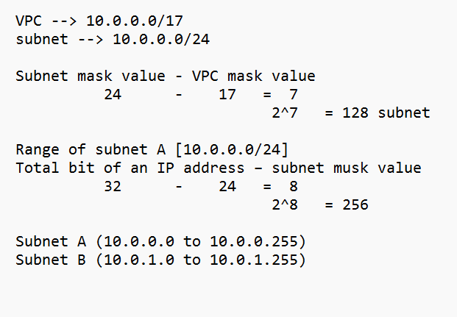

1. Go to the AWS Management Console 🡪 In the search bar, type "VPC" or find it under "Networking & Content Delivery" 🡪 Click on "**VPC"**

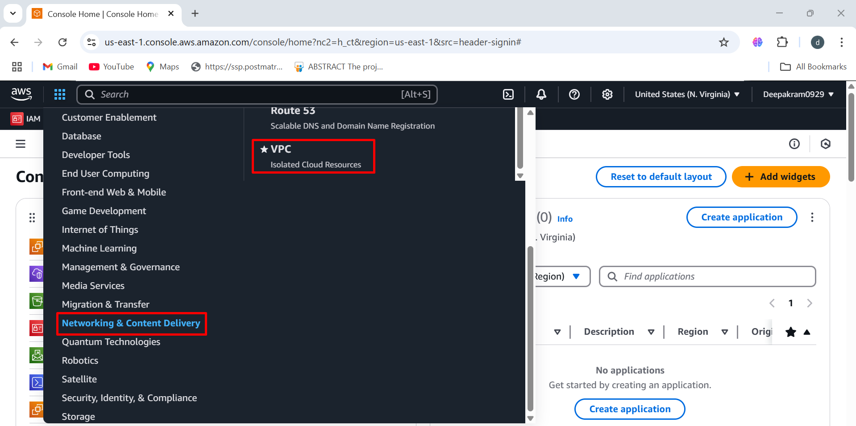

1. In the left-hand navigation pane, click on "Your VPCs" 🡪 Click the "Create VPC" button

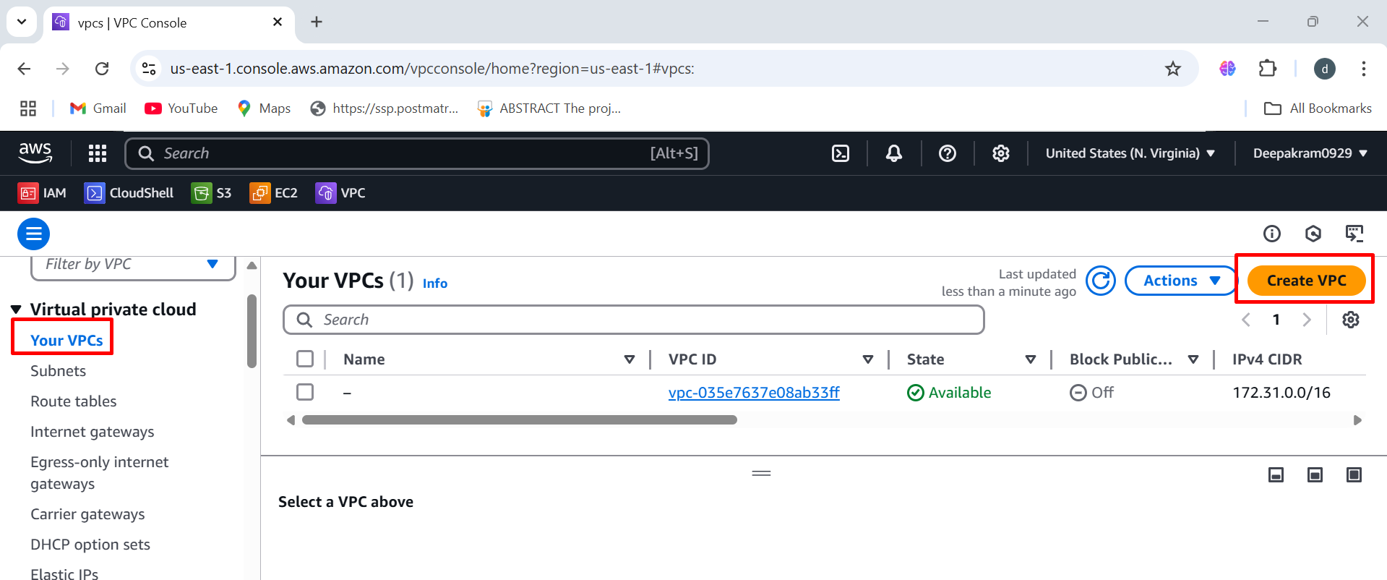

1. Under "Resources to create," select "VPC only" 🡪 Provide a "Name tag" for your VPC (e.g., "My-first-VPC")

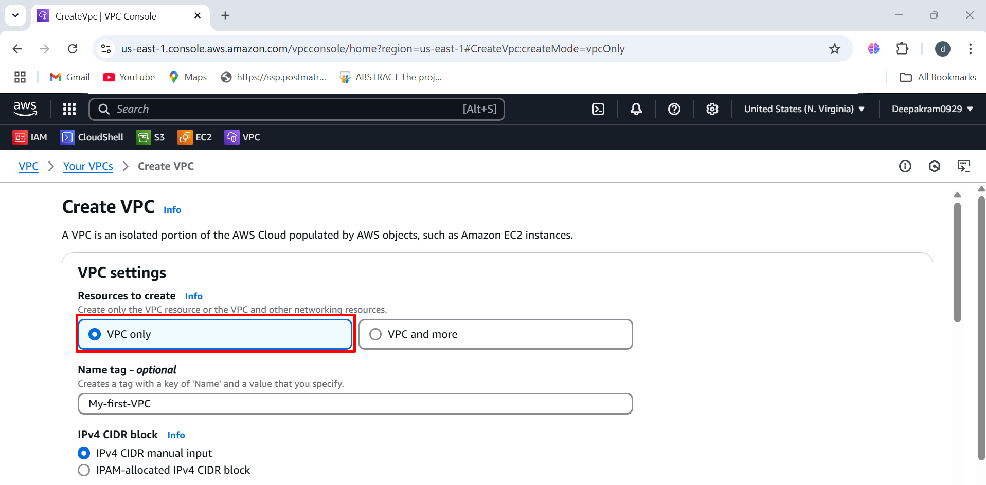

1. Ensure "IPv4 CIDR manual input" is selected 🡪 Enter the desired IPv4 CIDR block (e.g., 10.0.0.0/17). Note the CIDR block size restrictions

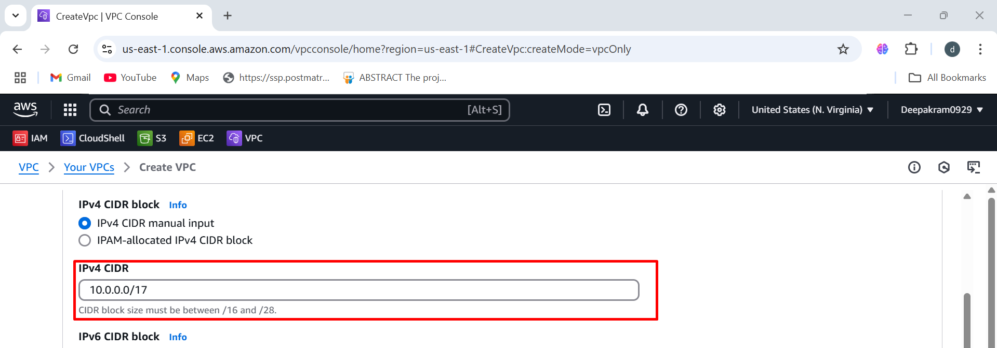

1. Click the "Create VPC" button

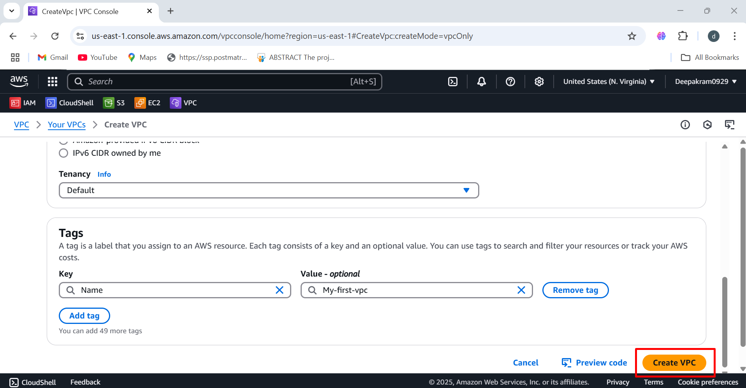

1. "Resource map" tab, providing a visual representation of your VPC and its associated resources

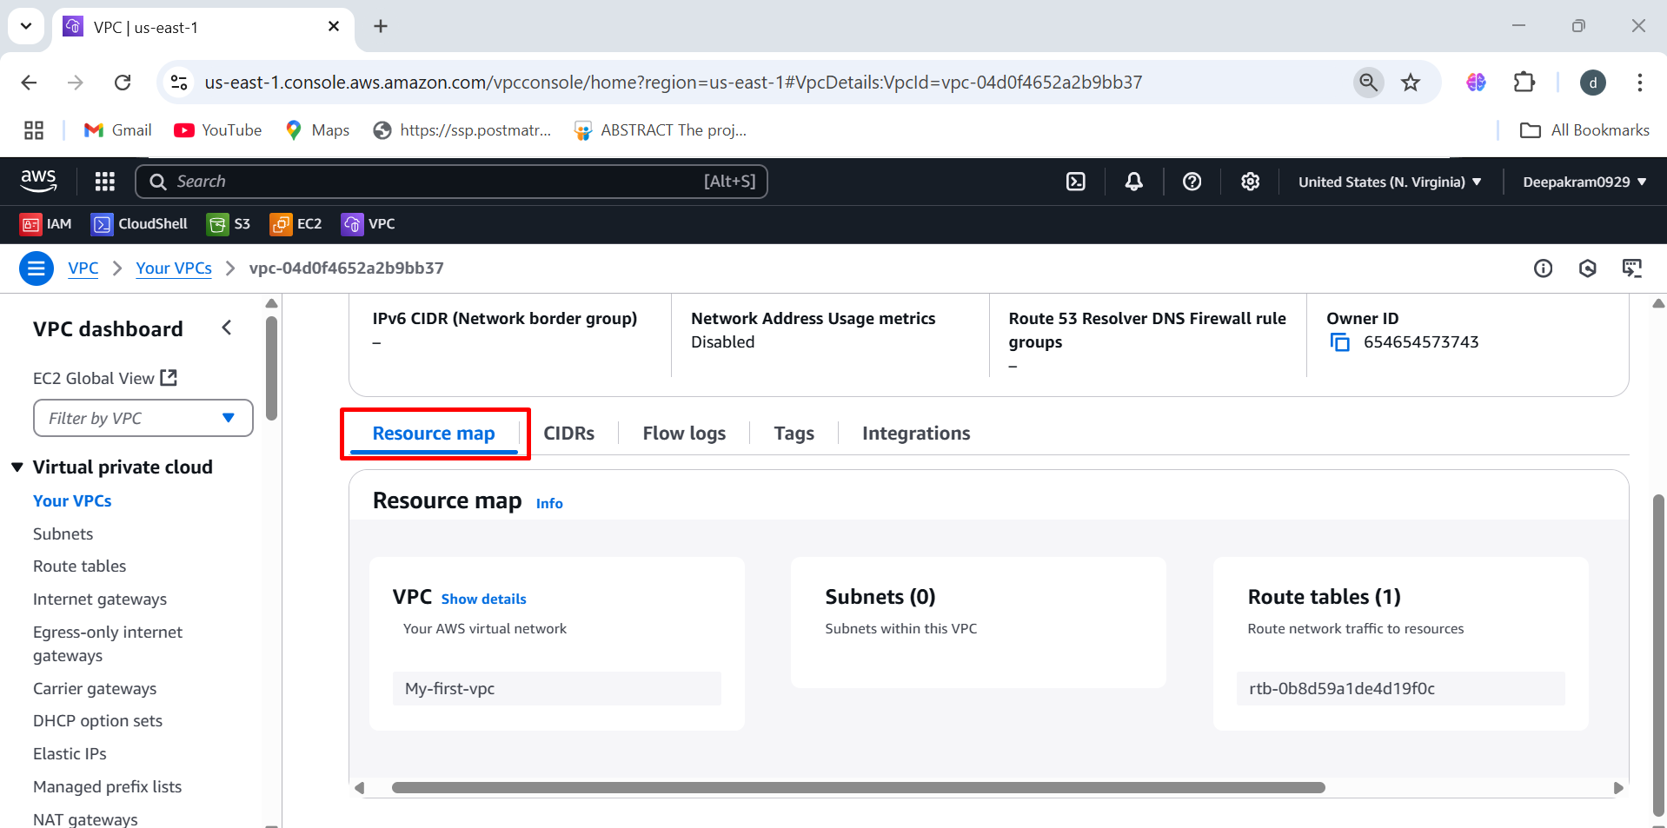

**Creation of subnets**

1. In the left-hand navigation pane, click on "Subnets" 🡪 Click the "Create subnet" button

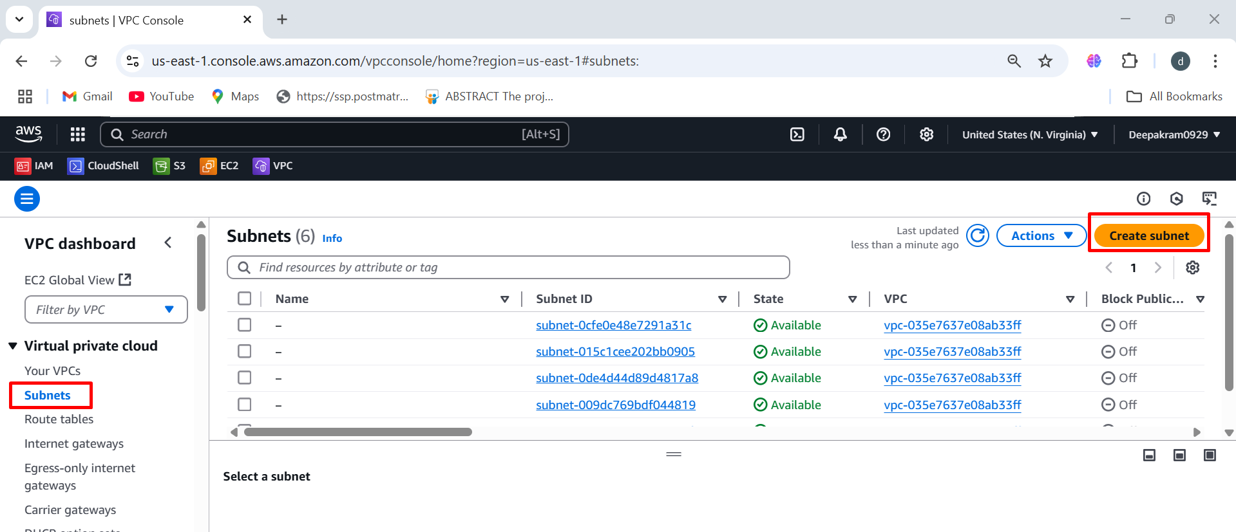

1. Select the VPC you created from the "VPC ID" dropdown menu

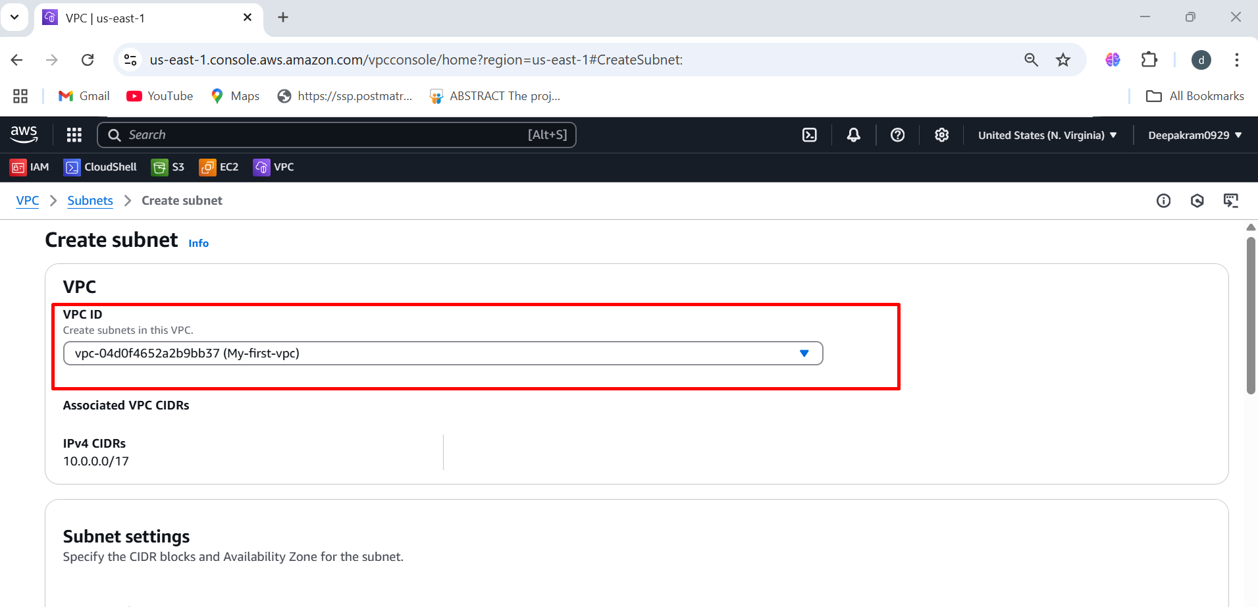

1. Enter a "Subnet name" (e.g., "subnet-us-east-1a")

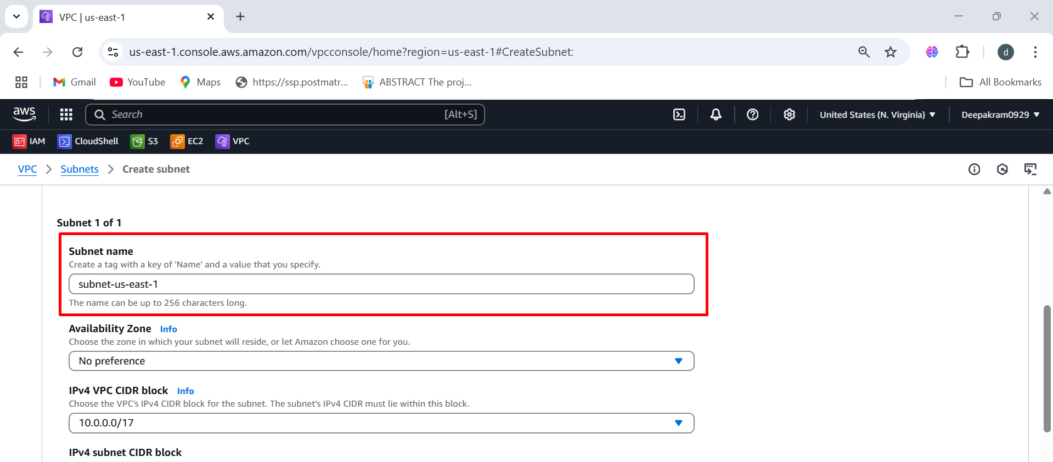

1. Choose an "Availability Zone" from the dropdown menu (e.g., "us-east-1a")

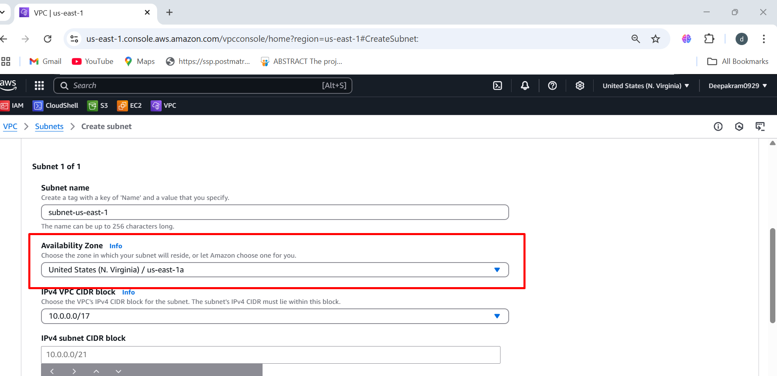

1. Enter the "IPv4 subnet CIDR block" (e.g., 10.0.0.0/26). This CIDR block must be a subset of the VPC's CIDR block

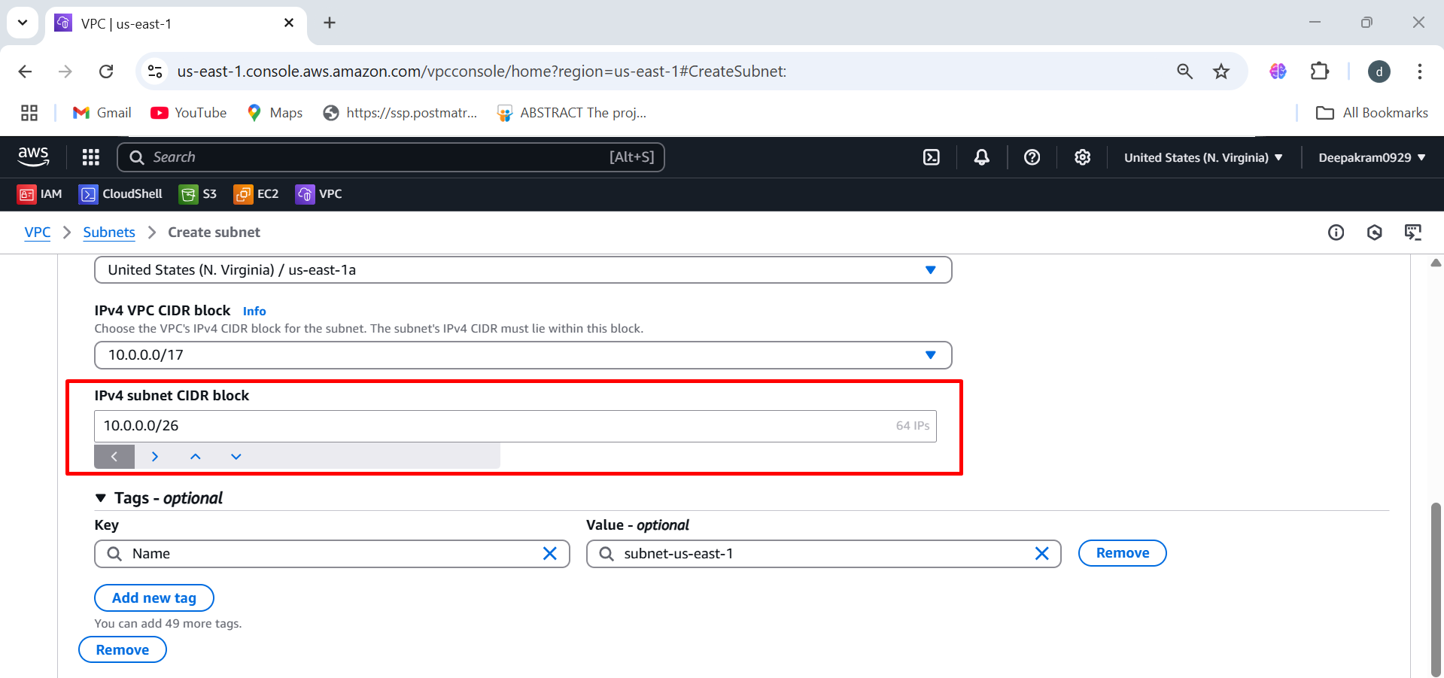

1. Click the "Create subnet" button

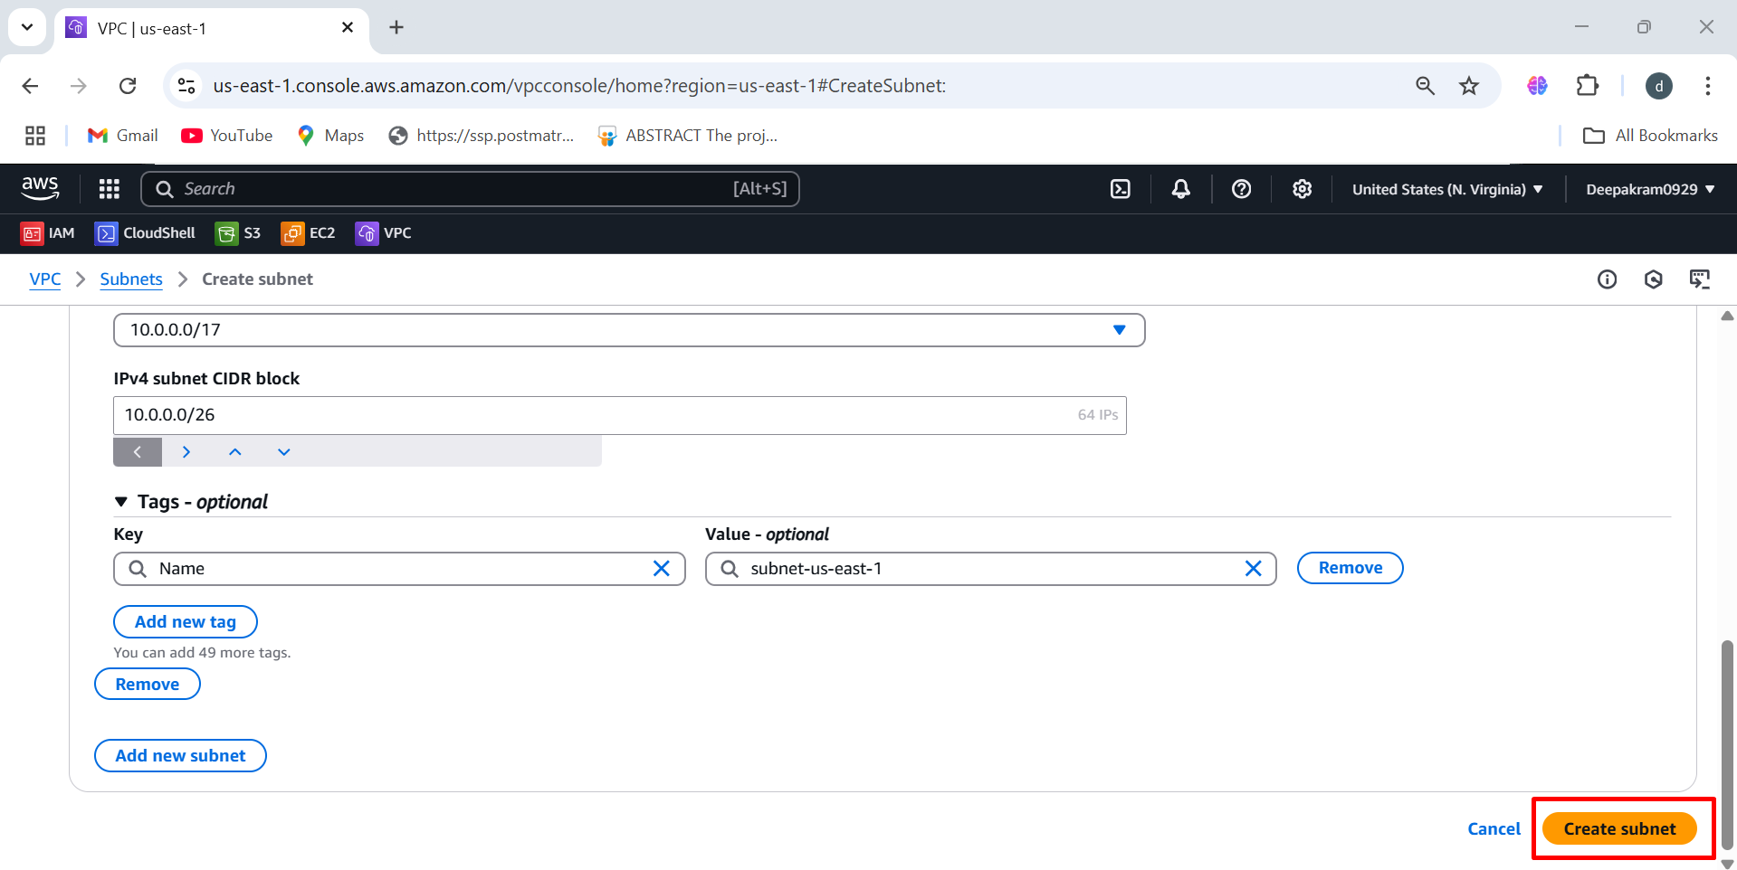

1. Provide the same steps to create subnet in different region 🡪 Enter a different "IPv4 subnet CIDR block" (e.g., 10.0.1.0/26)

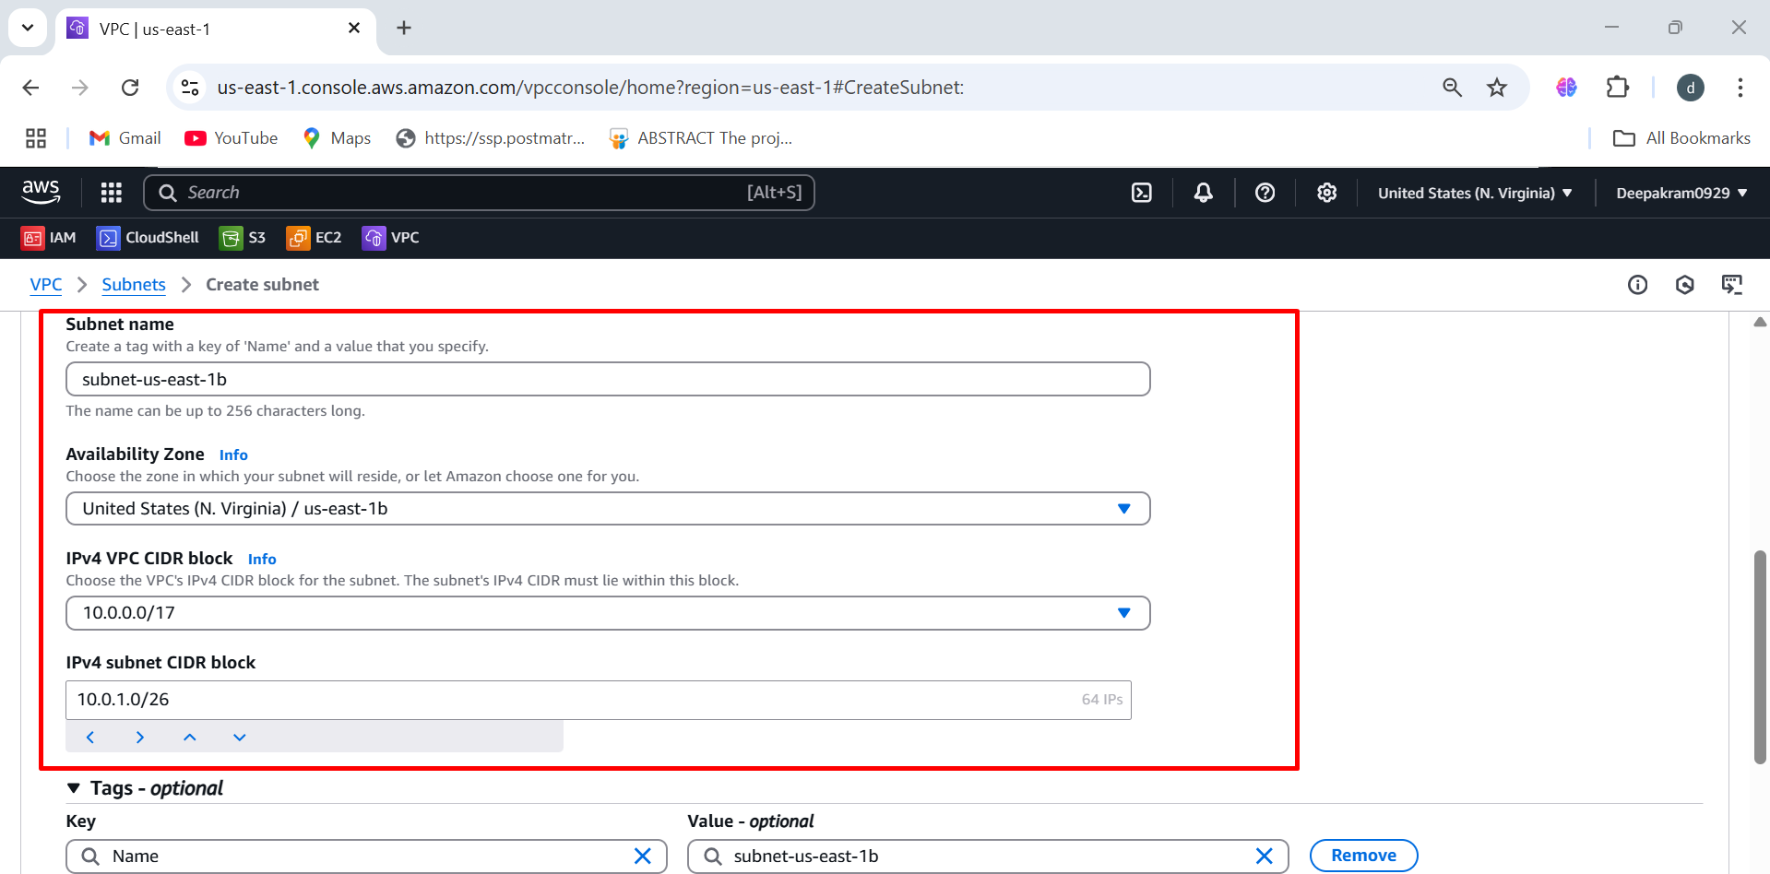

1. Subnets page with the two newly created subnets

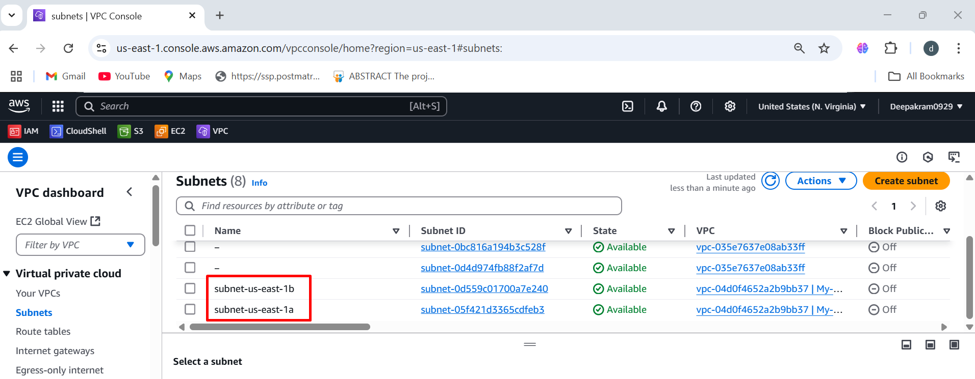

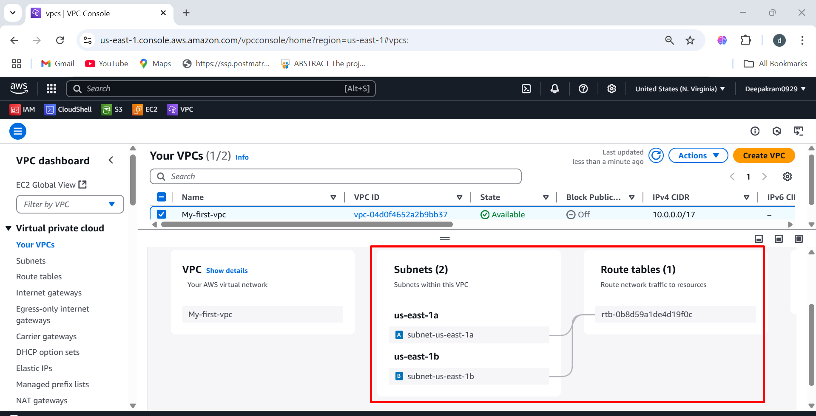

If your are creating public subnet we need to enable auto assign IPV4 address

1. Subnet 🡪 Action 🡪 Edit subnet setting 🡪 Check Auto IPV4 🡪 Save

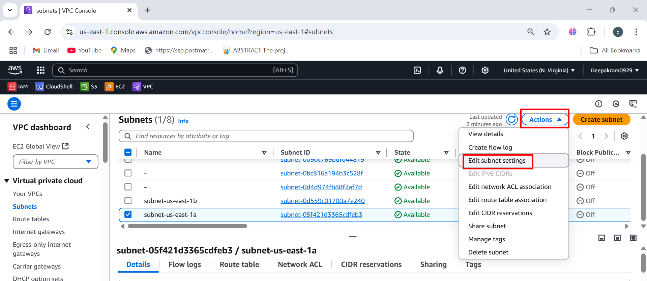

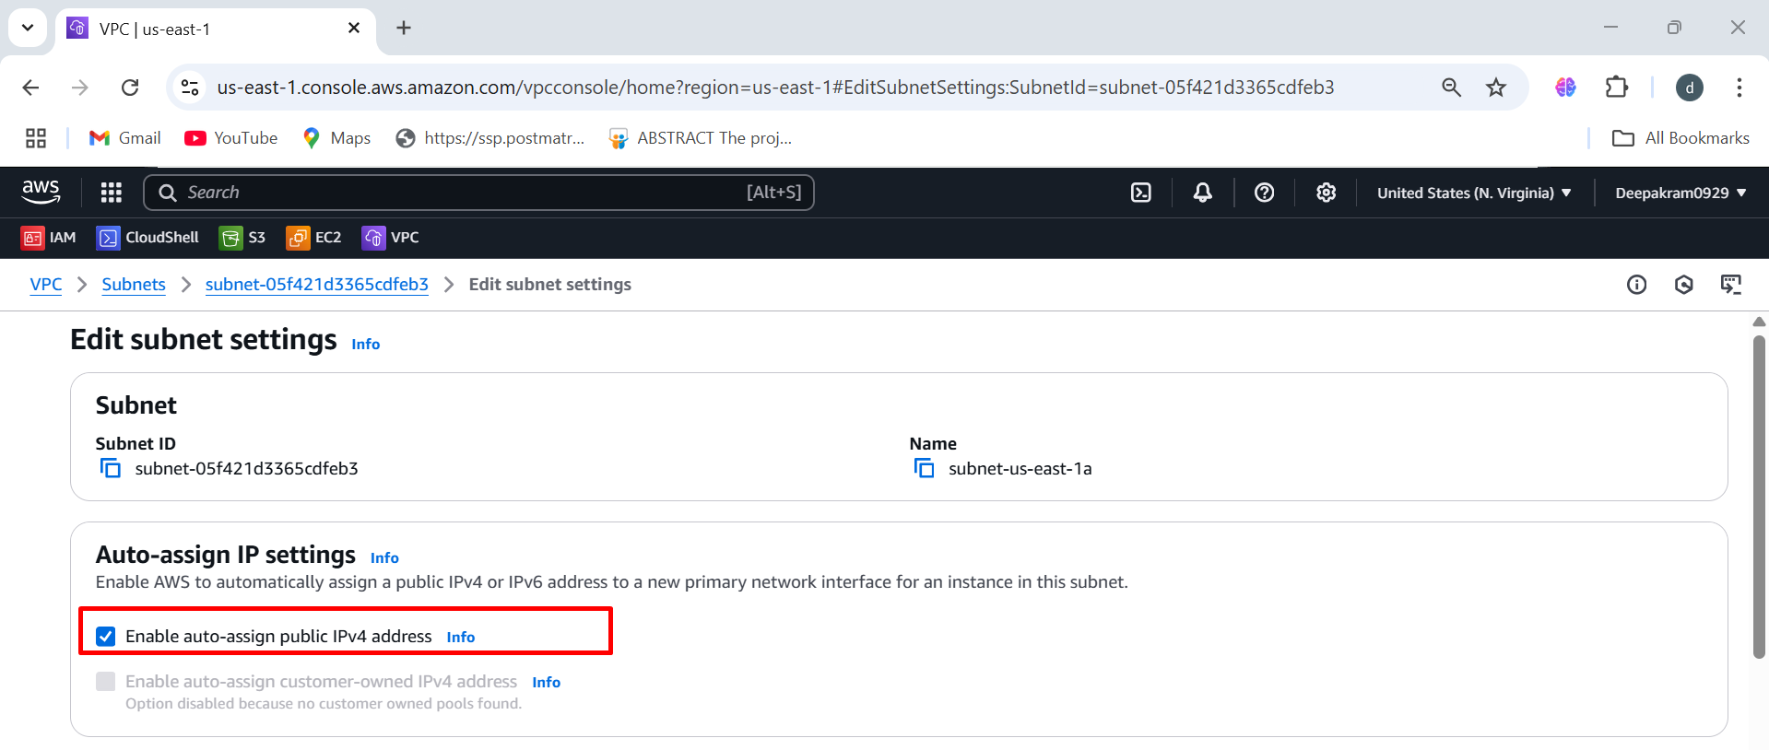

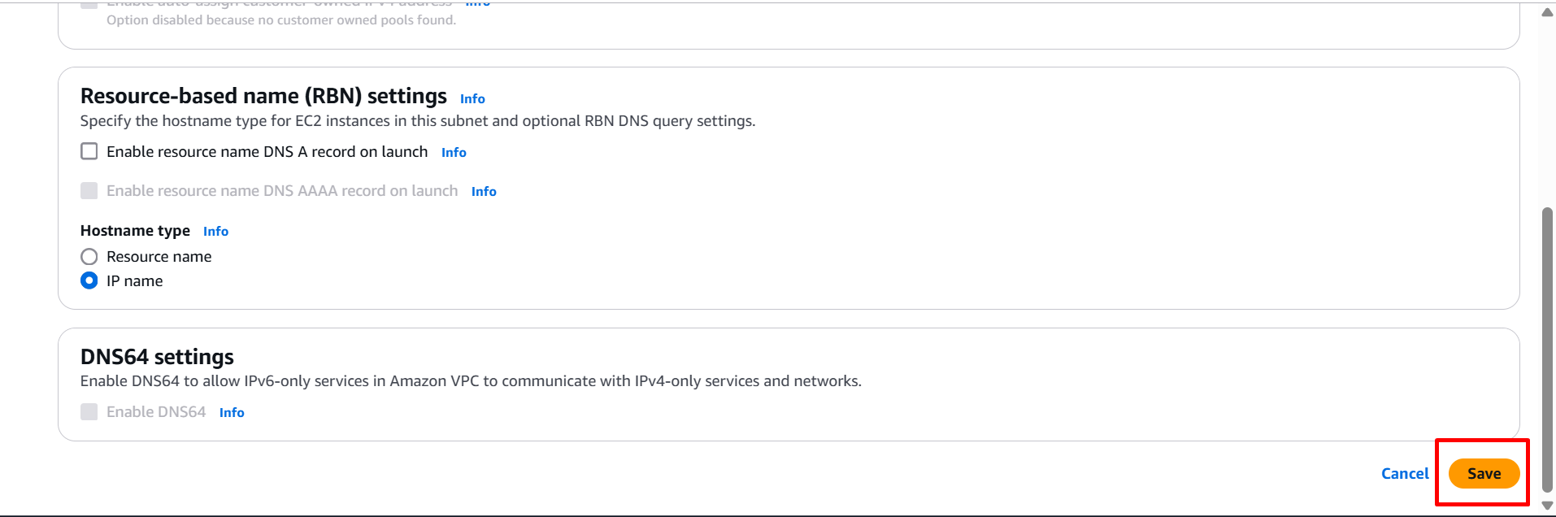

**Creating internet gate way**

1. VPC 🡪 IGW 🡪 Create IGW 🡪 Name 🡪 Create

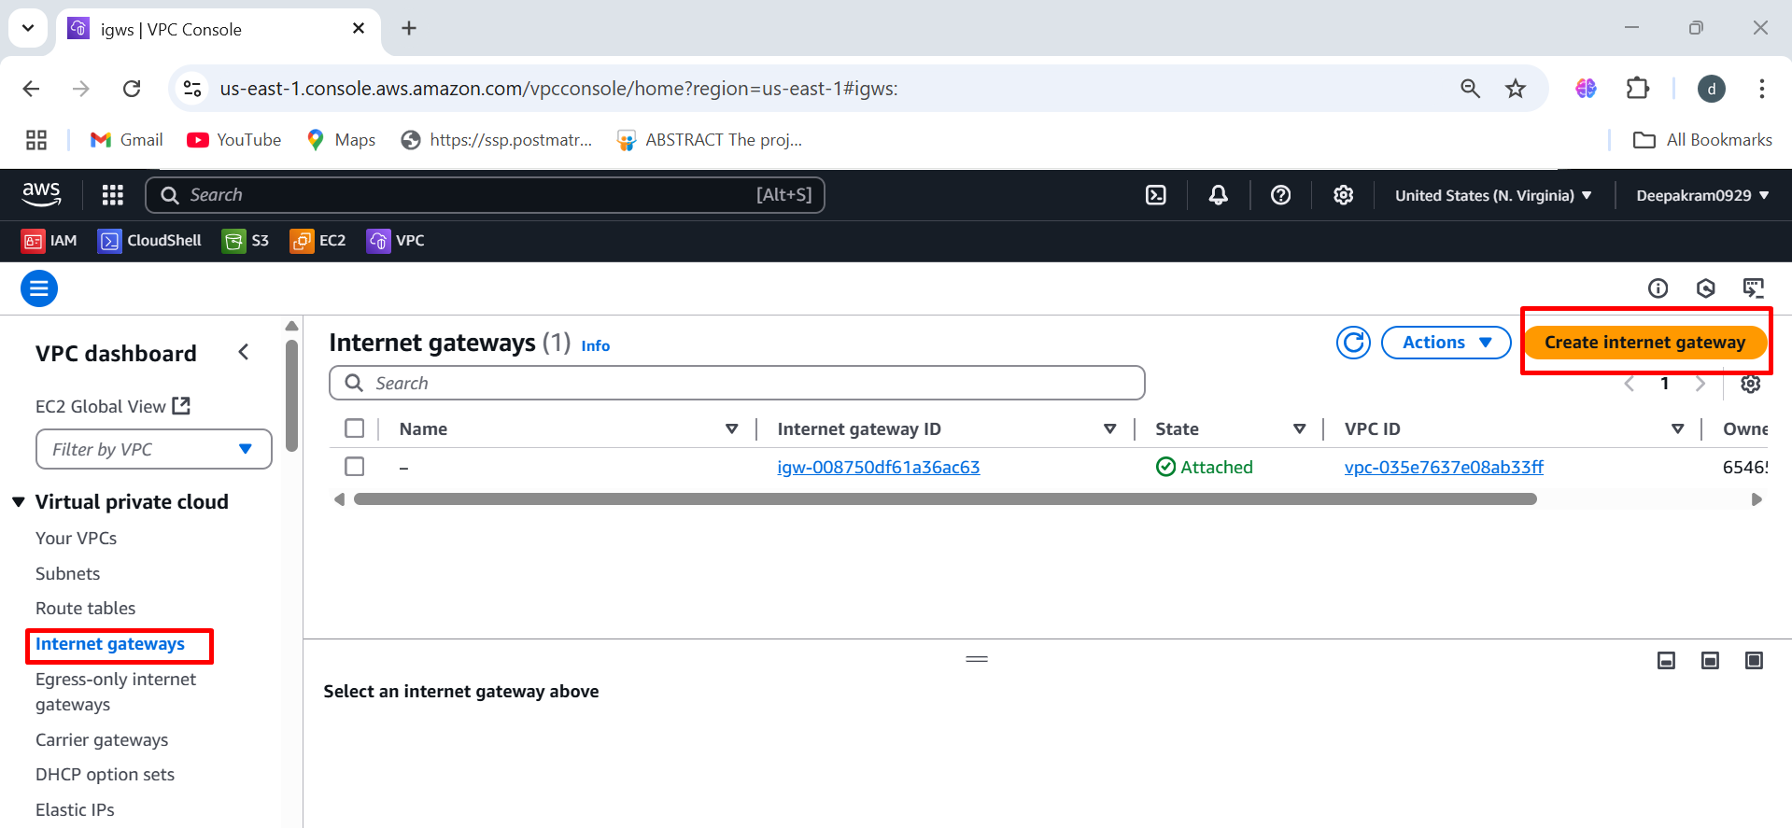

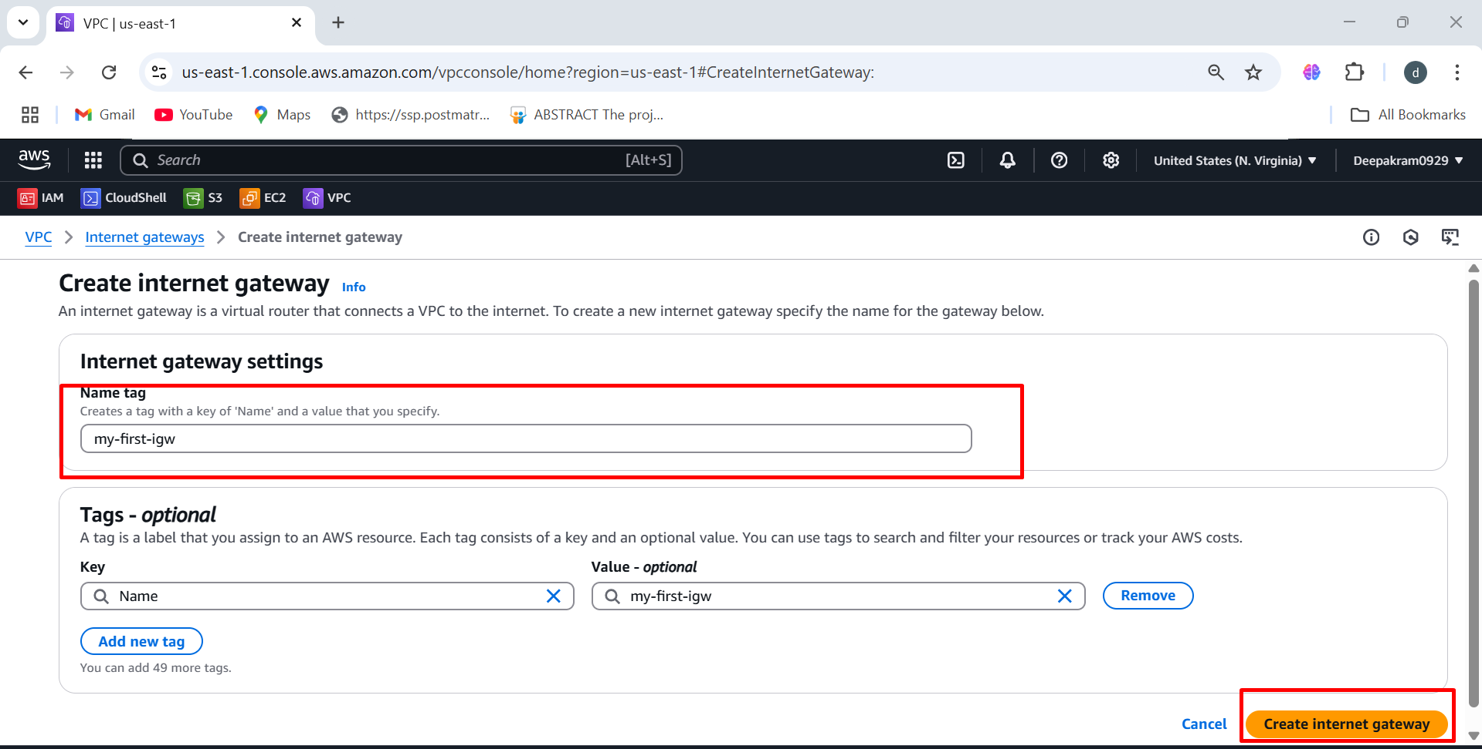

We need to attach to vpc

1. IGW 🡪 Action Attach to VPC 🡪 Select VPC 🡪 Attach

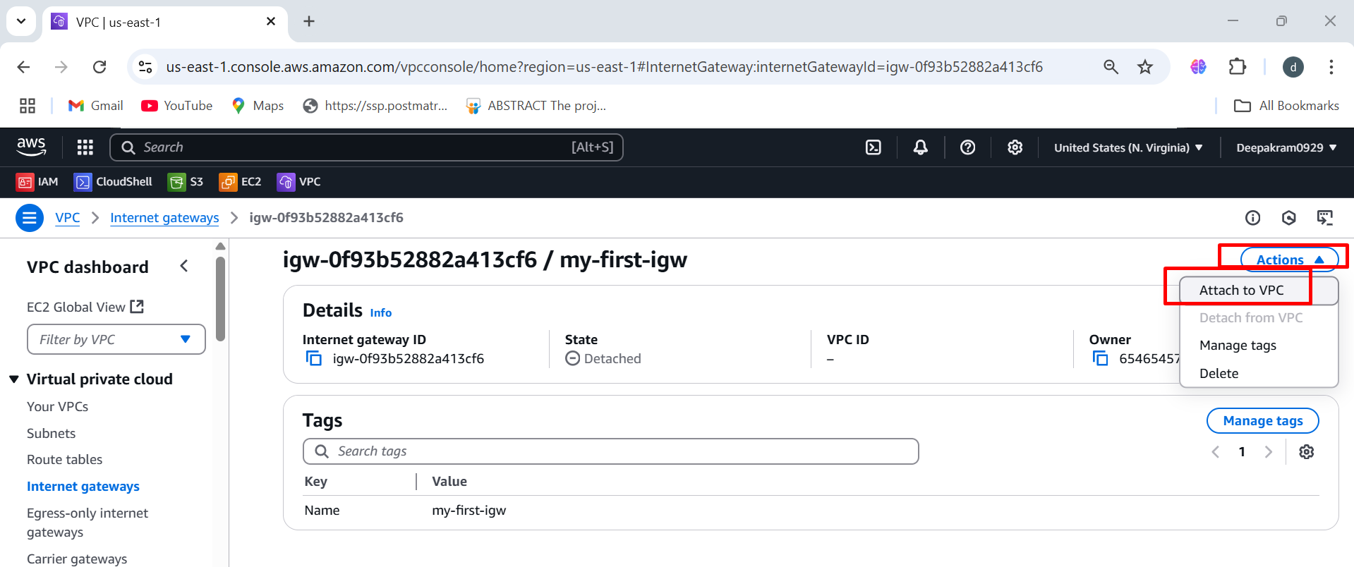

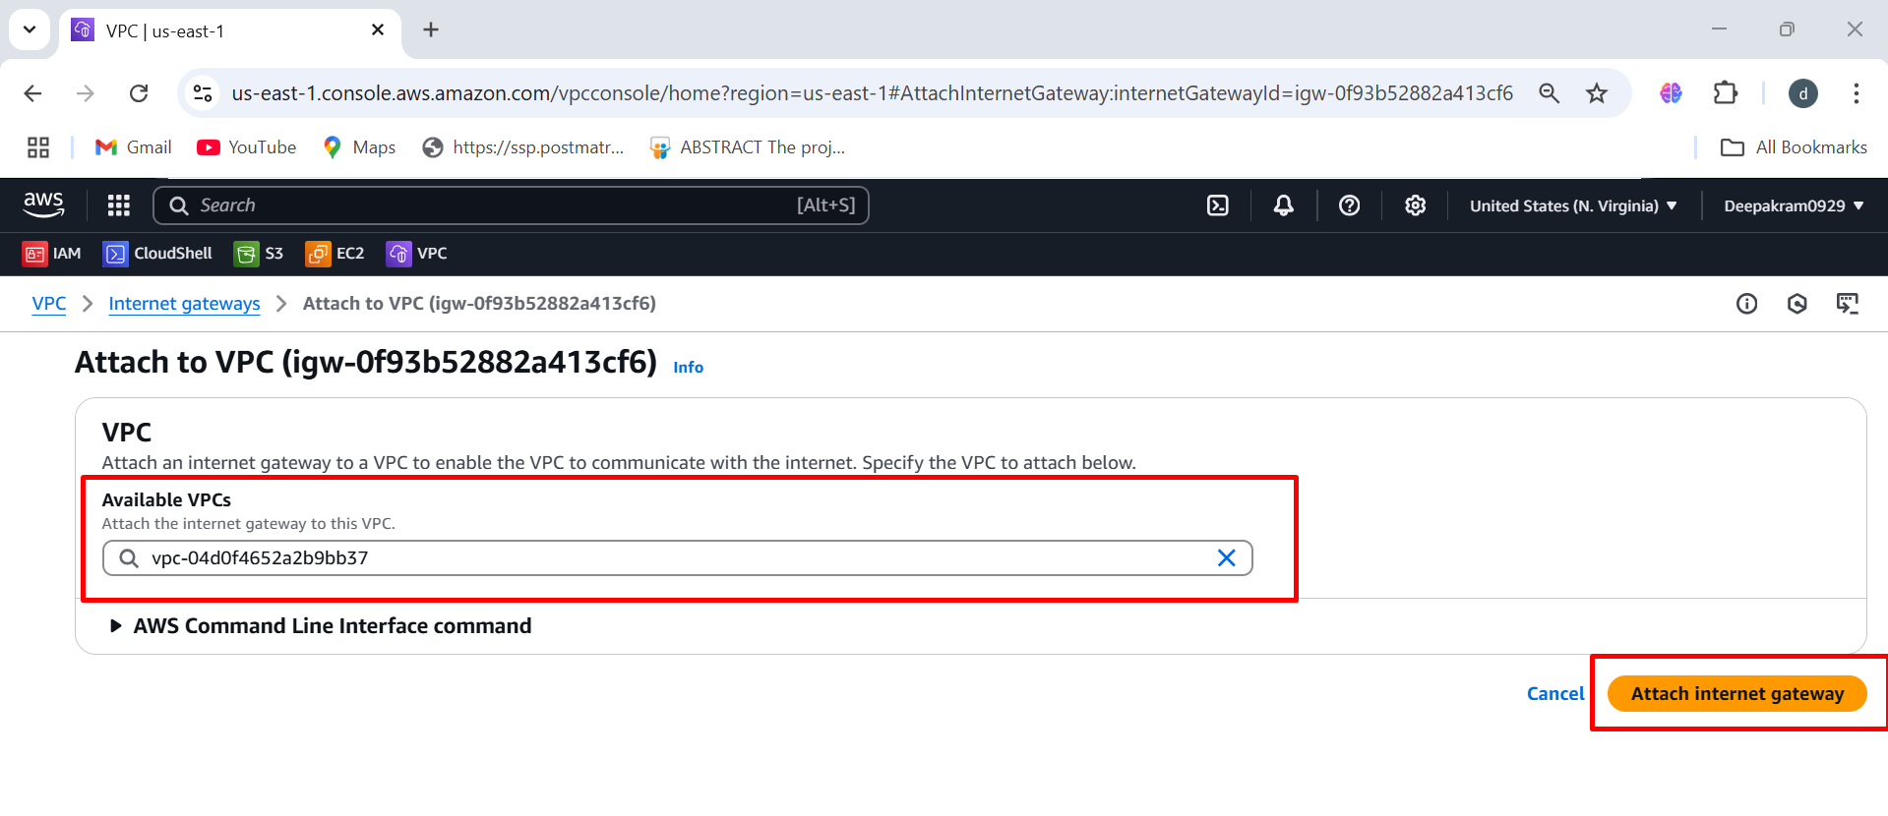

Still Route table is not connected to IGW

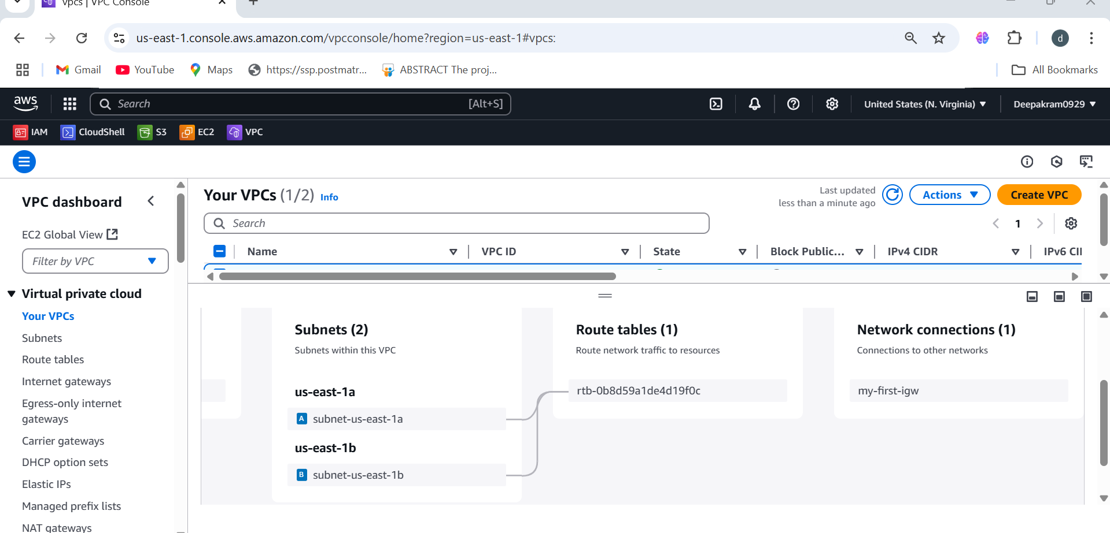

To provide the connection b/w Route table & IGW

1. VPC 🡪 Route table 🡪 Actions 🡪 Edit routes 🡪 Add Route

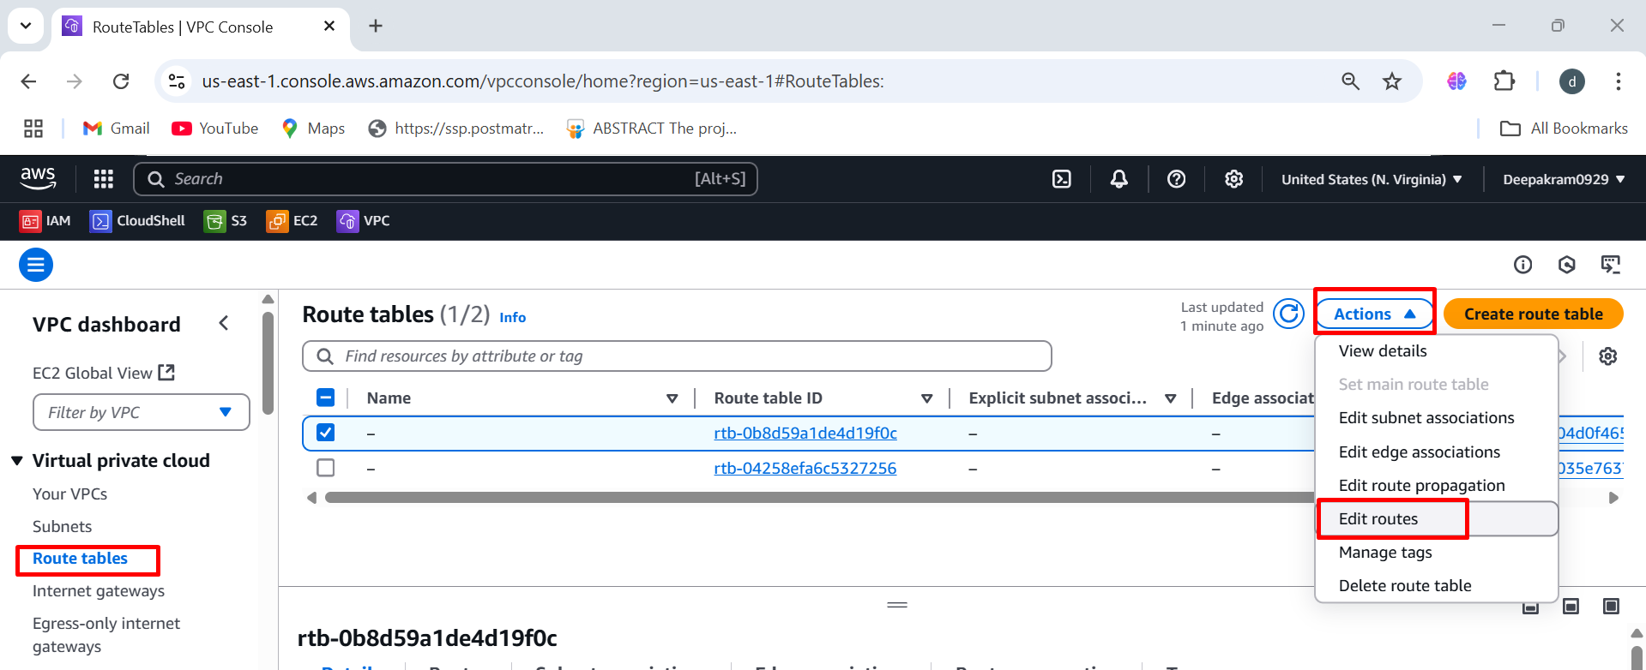

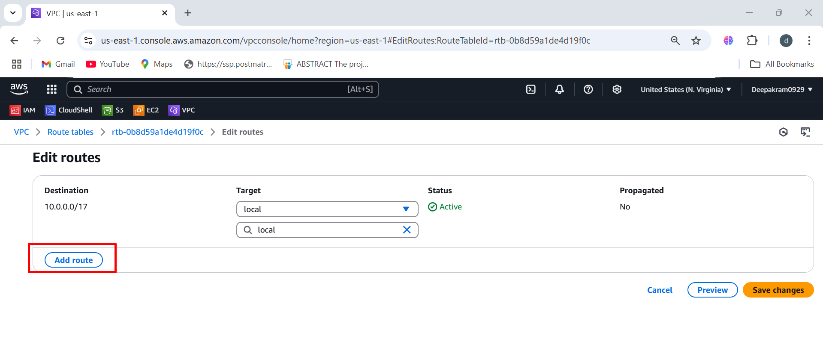

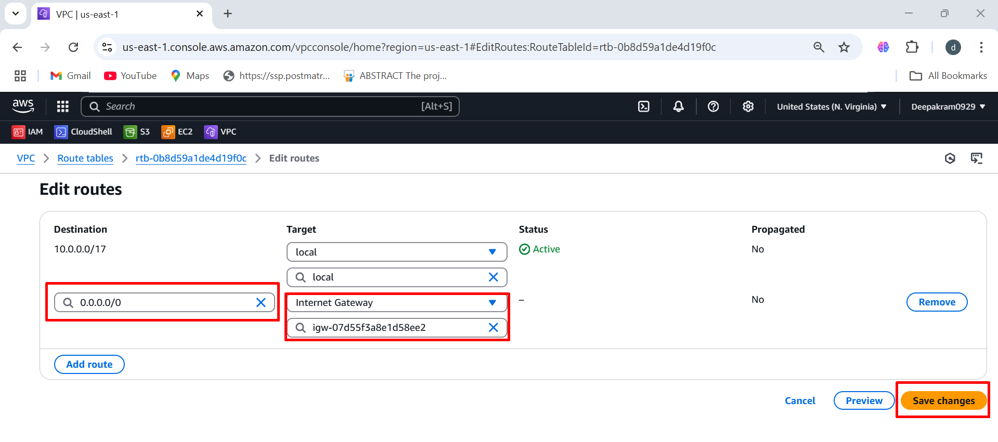

Connection b/w Route table and IGW

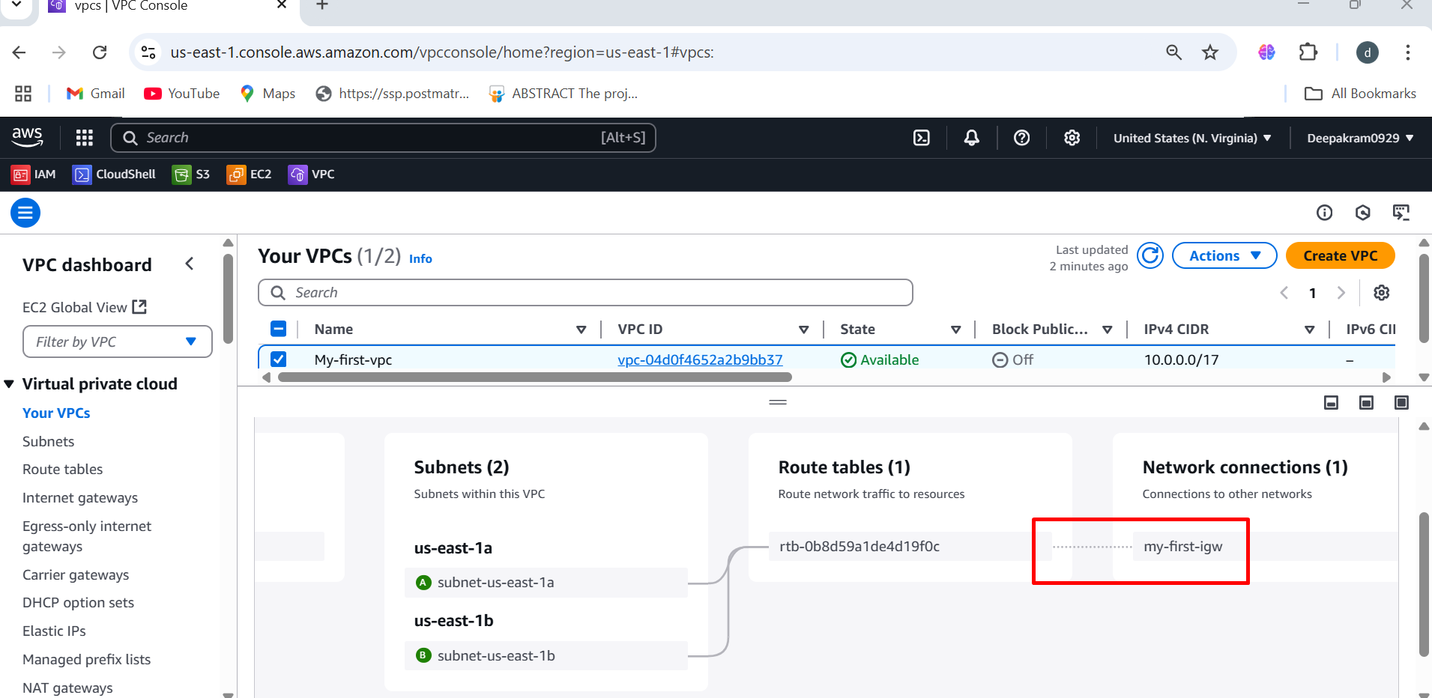

**To Create EC2 instances**

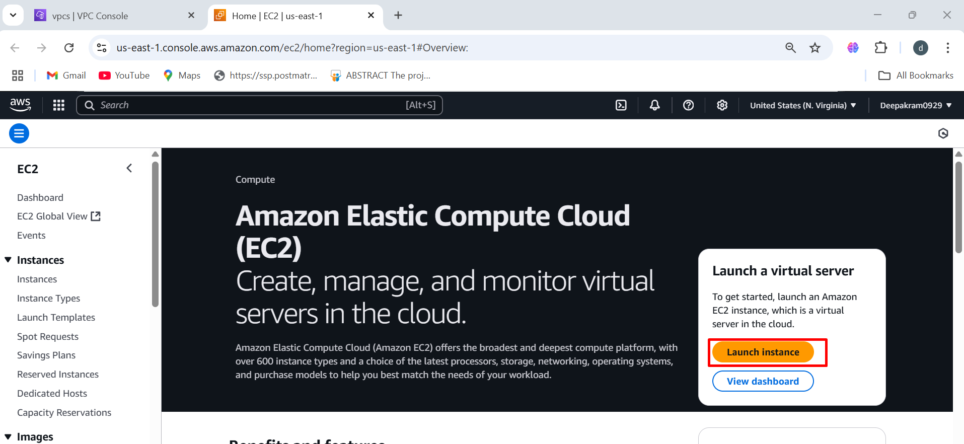

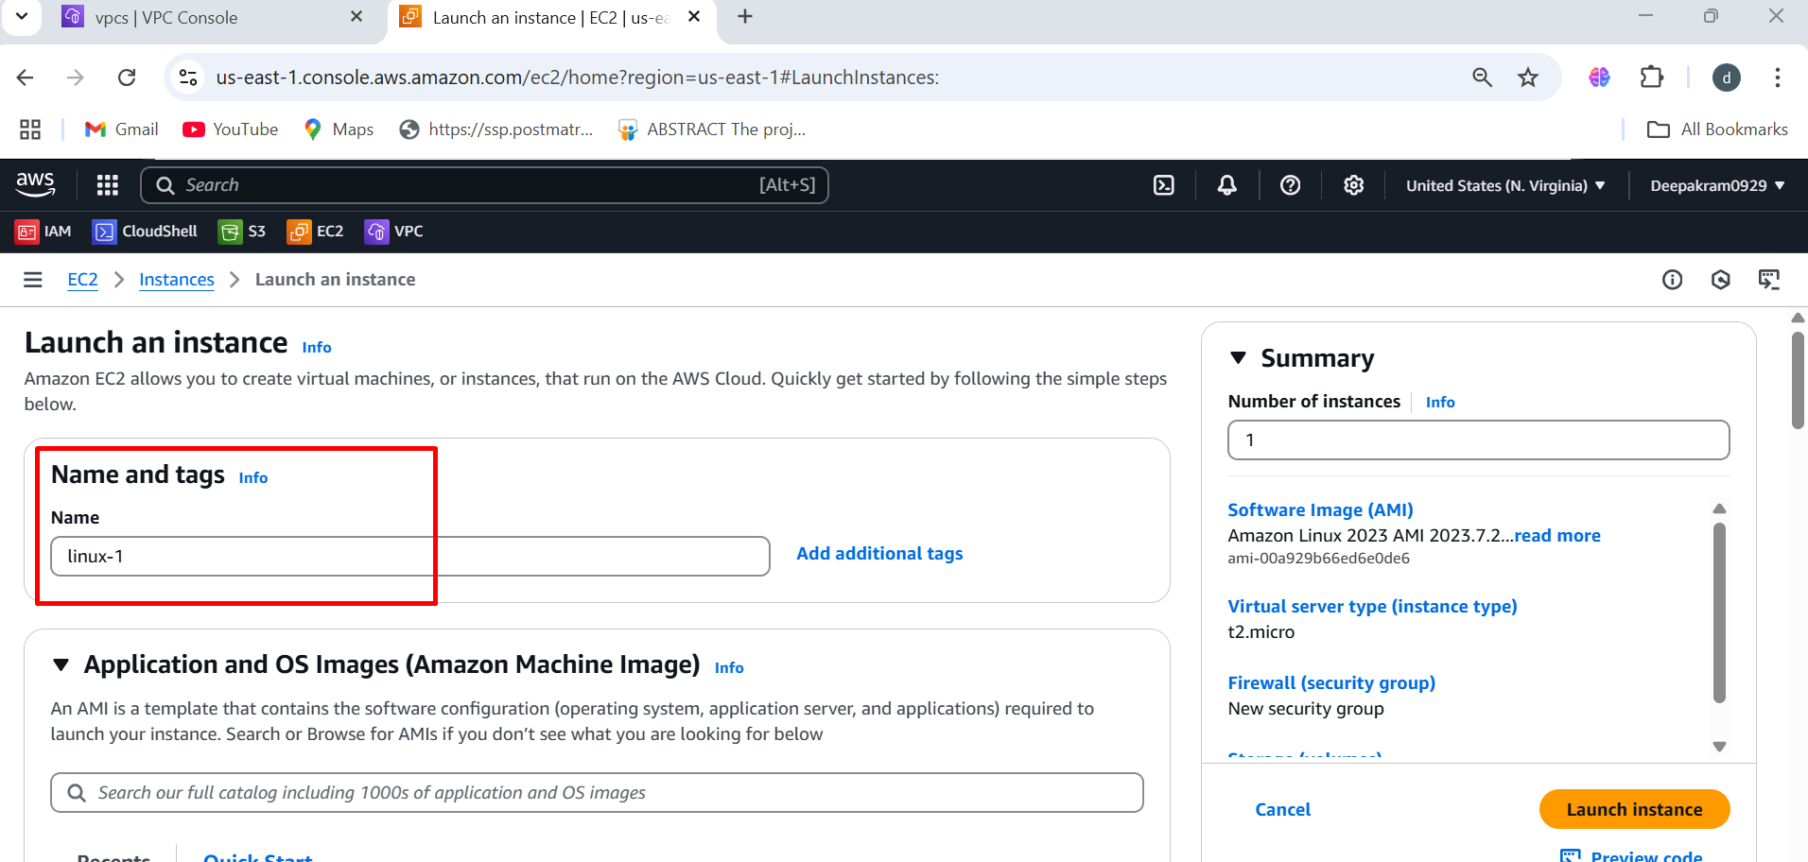

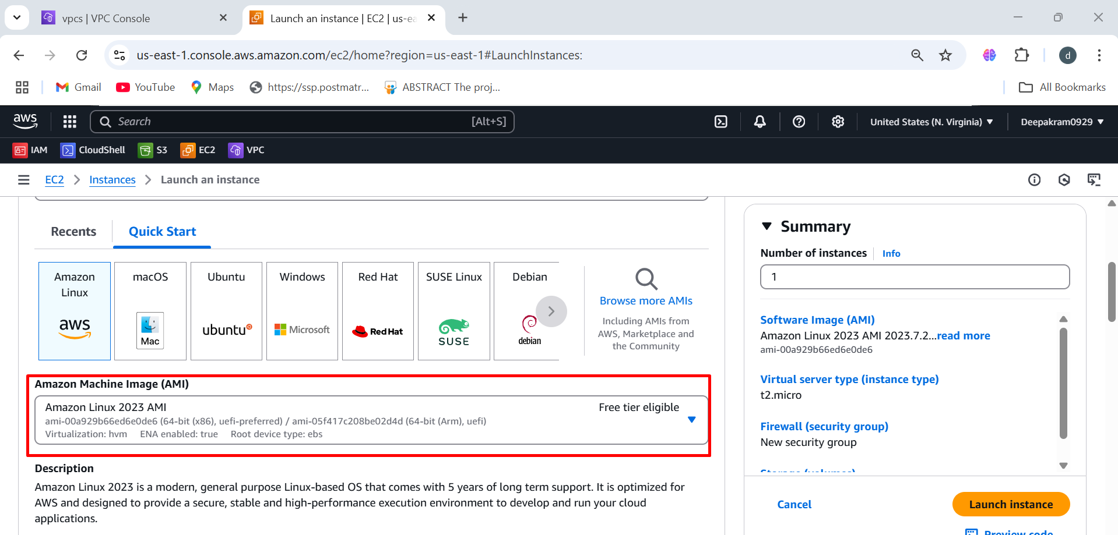

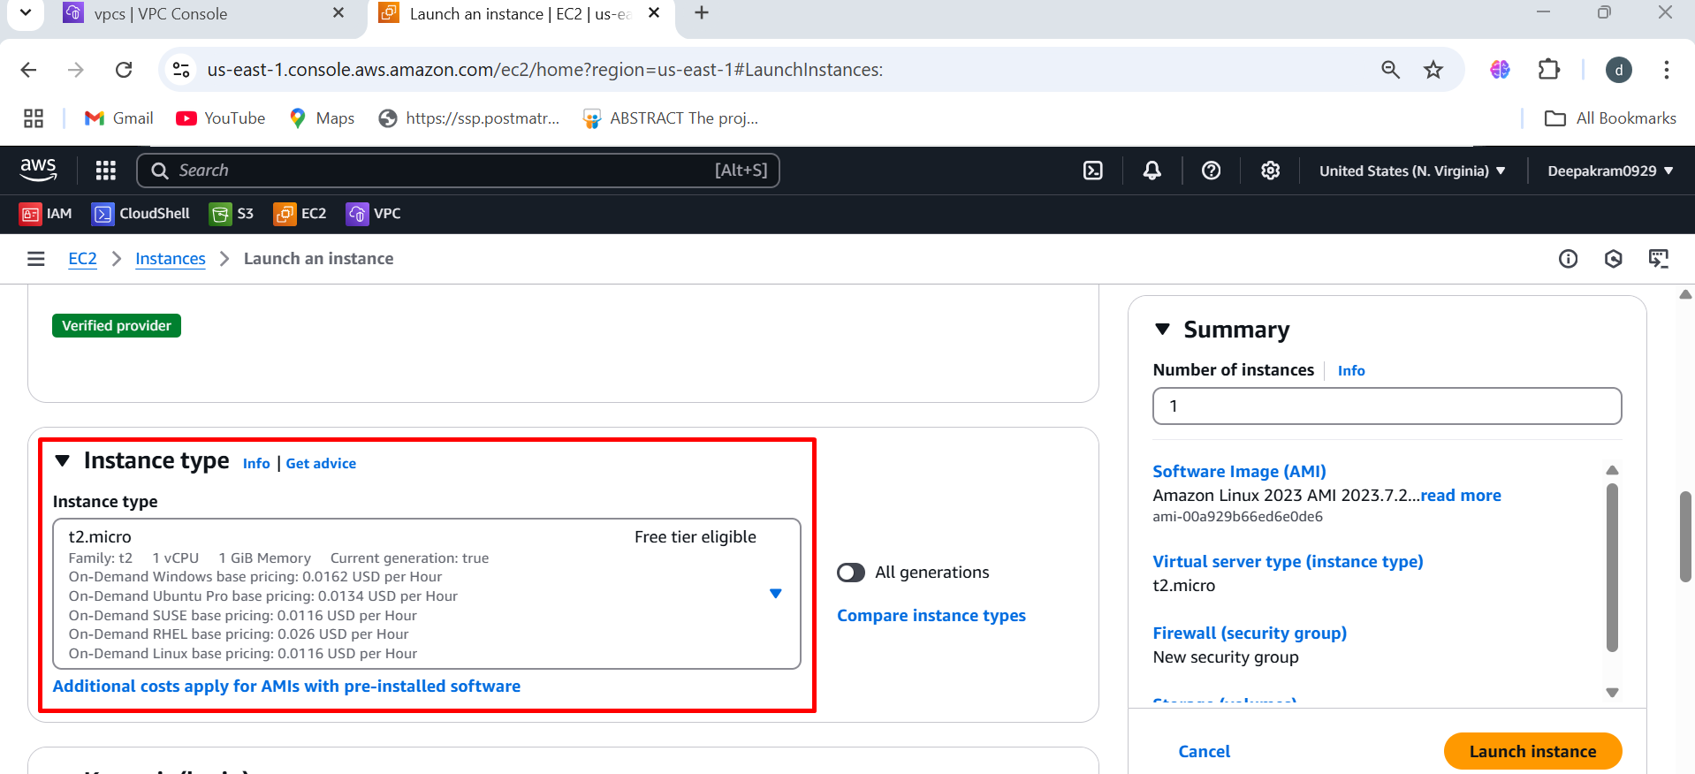

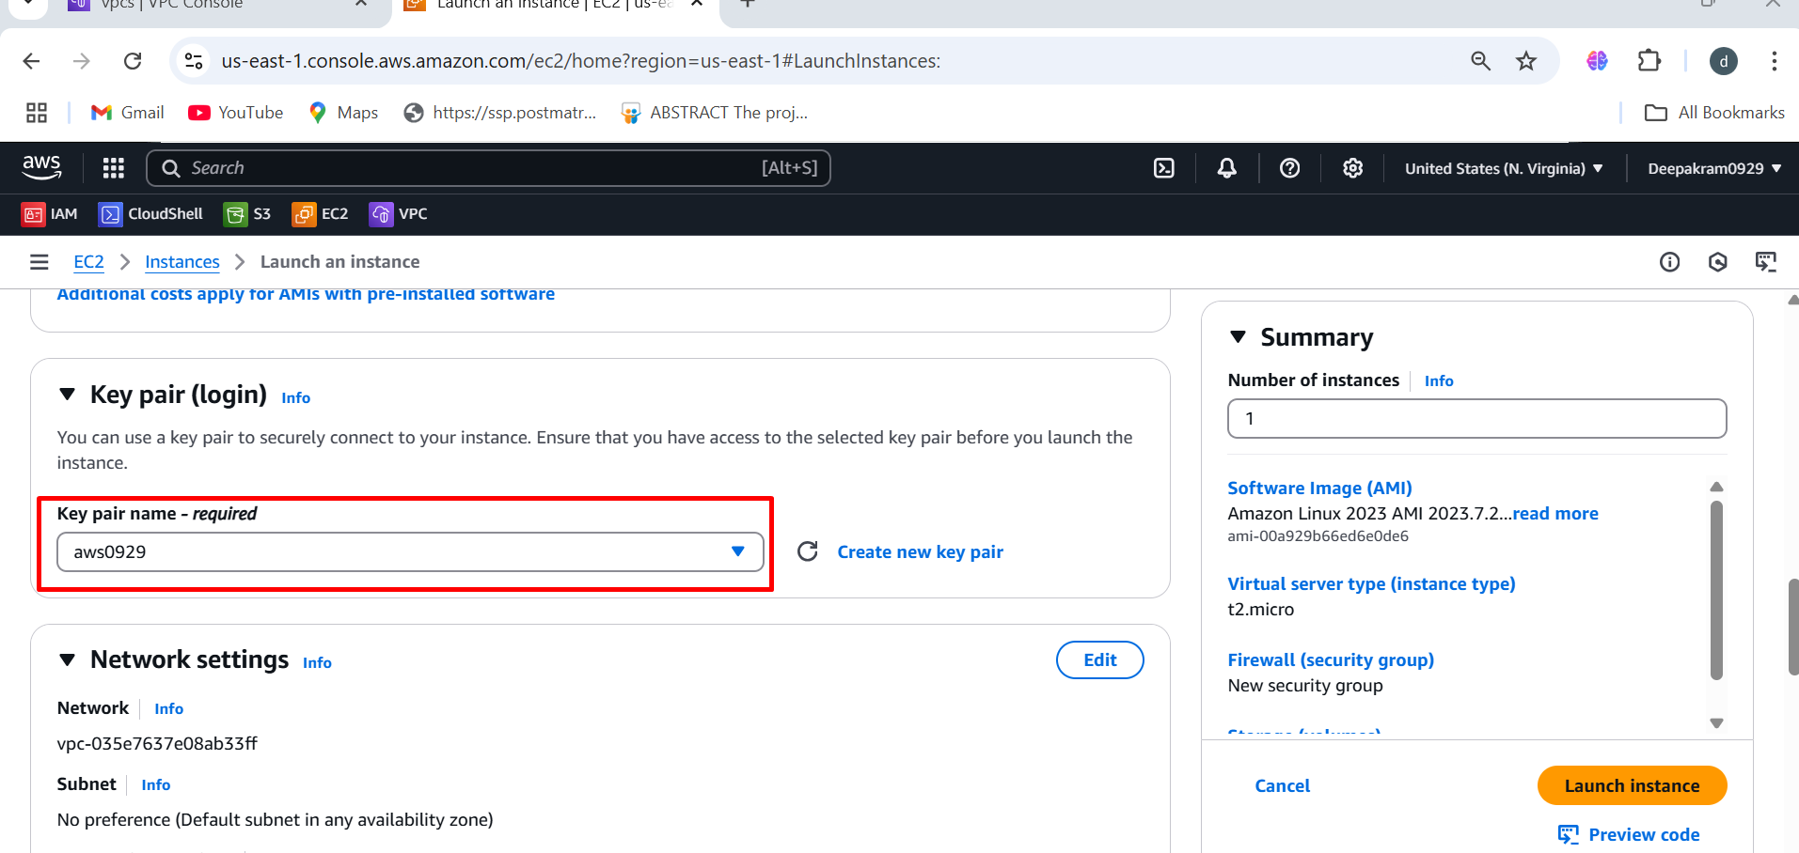

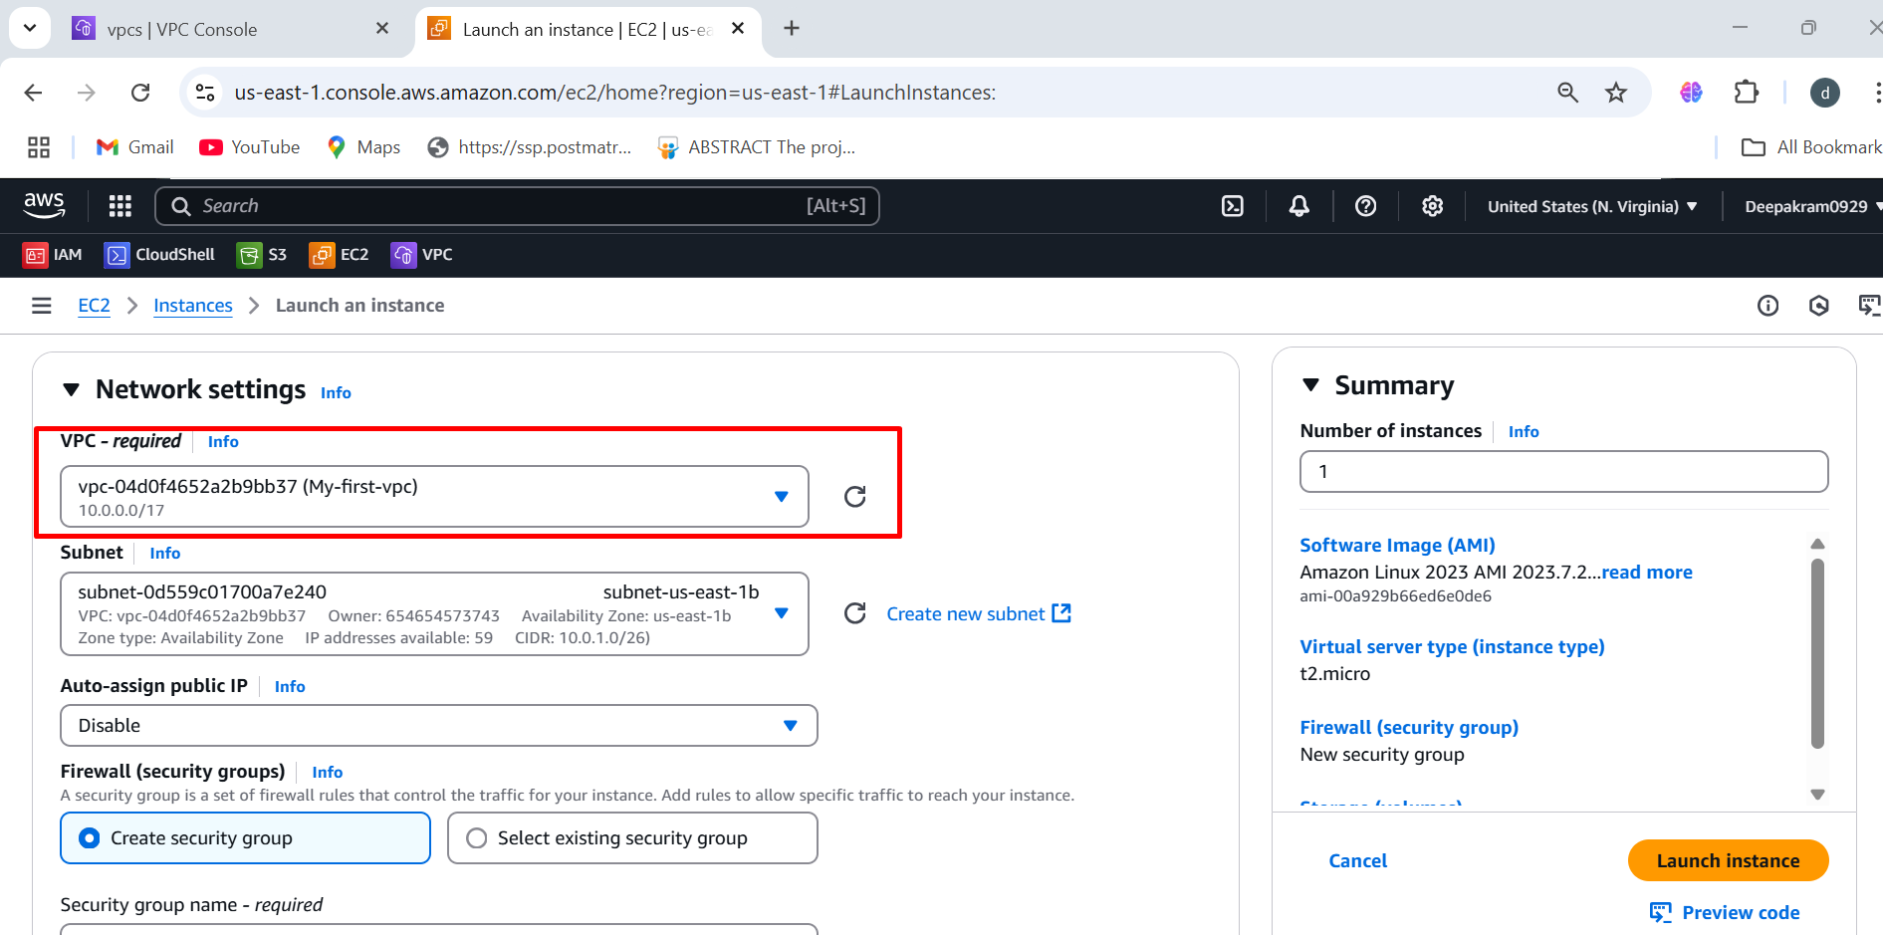

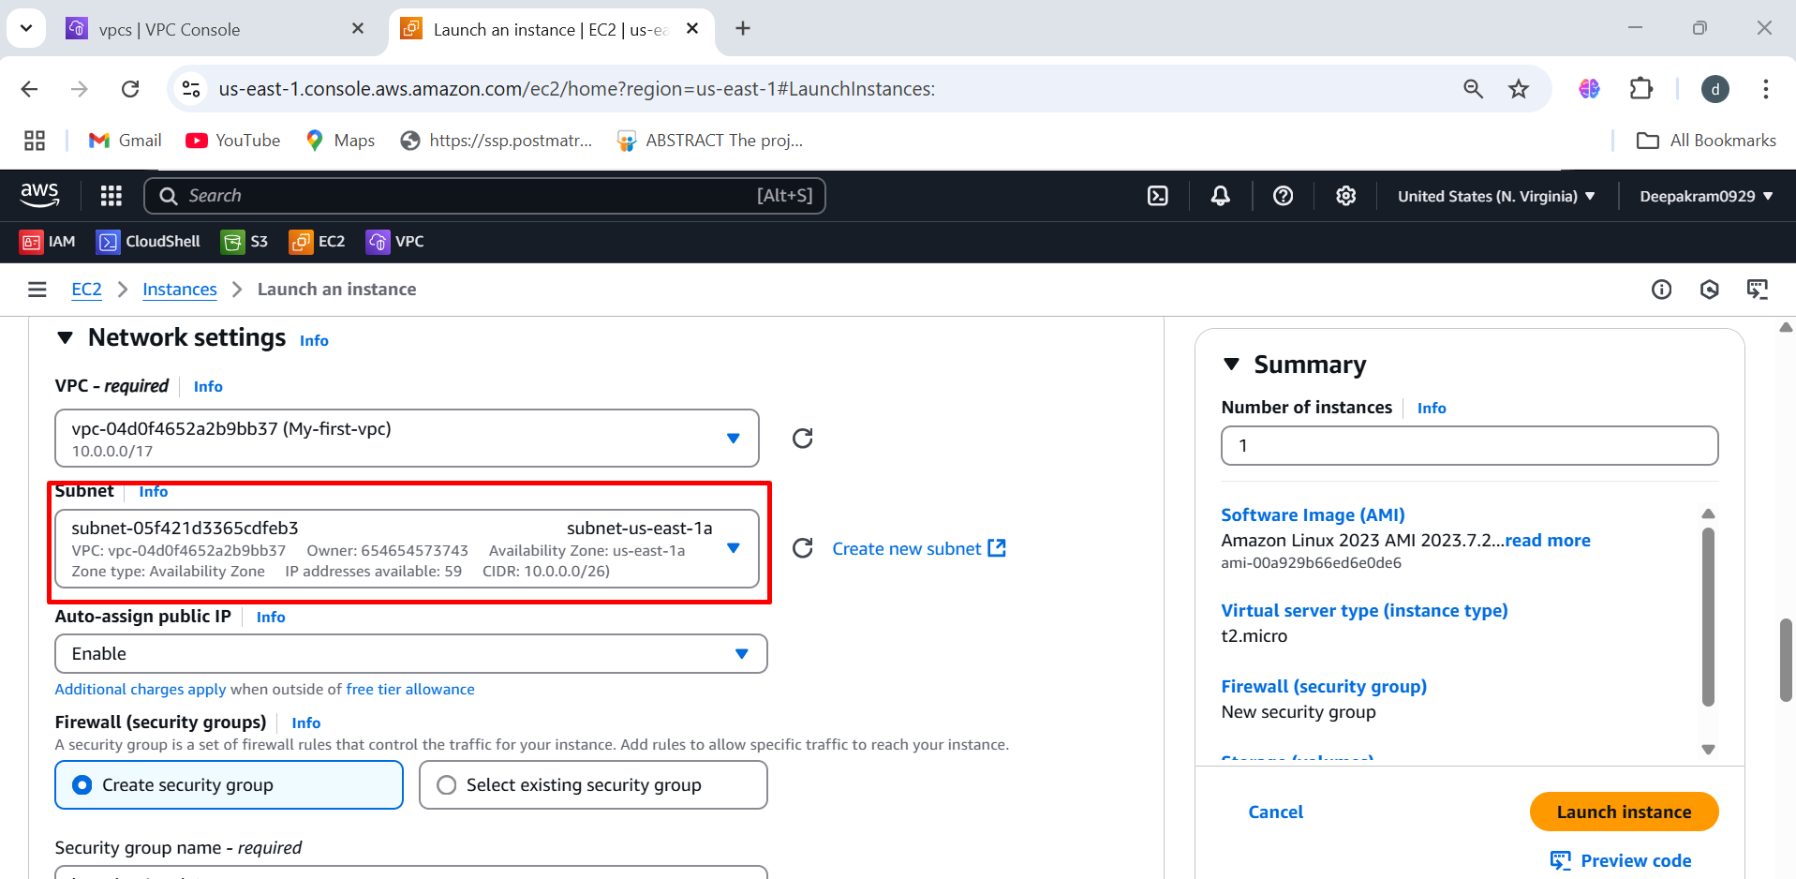

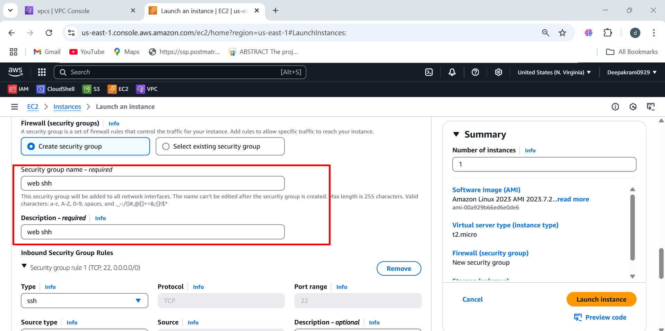

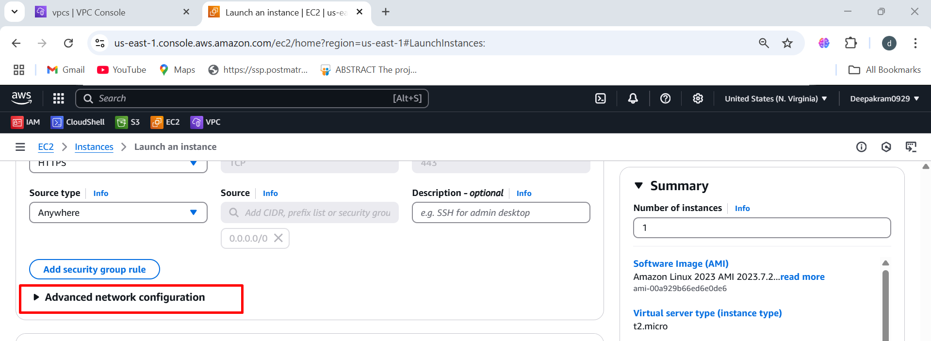

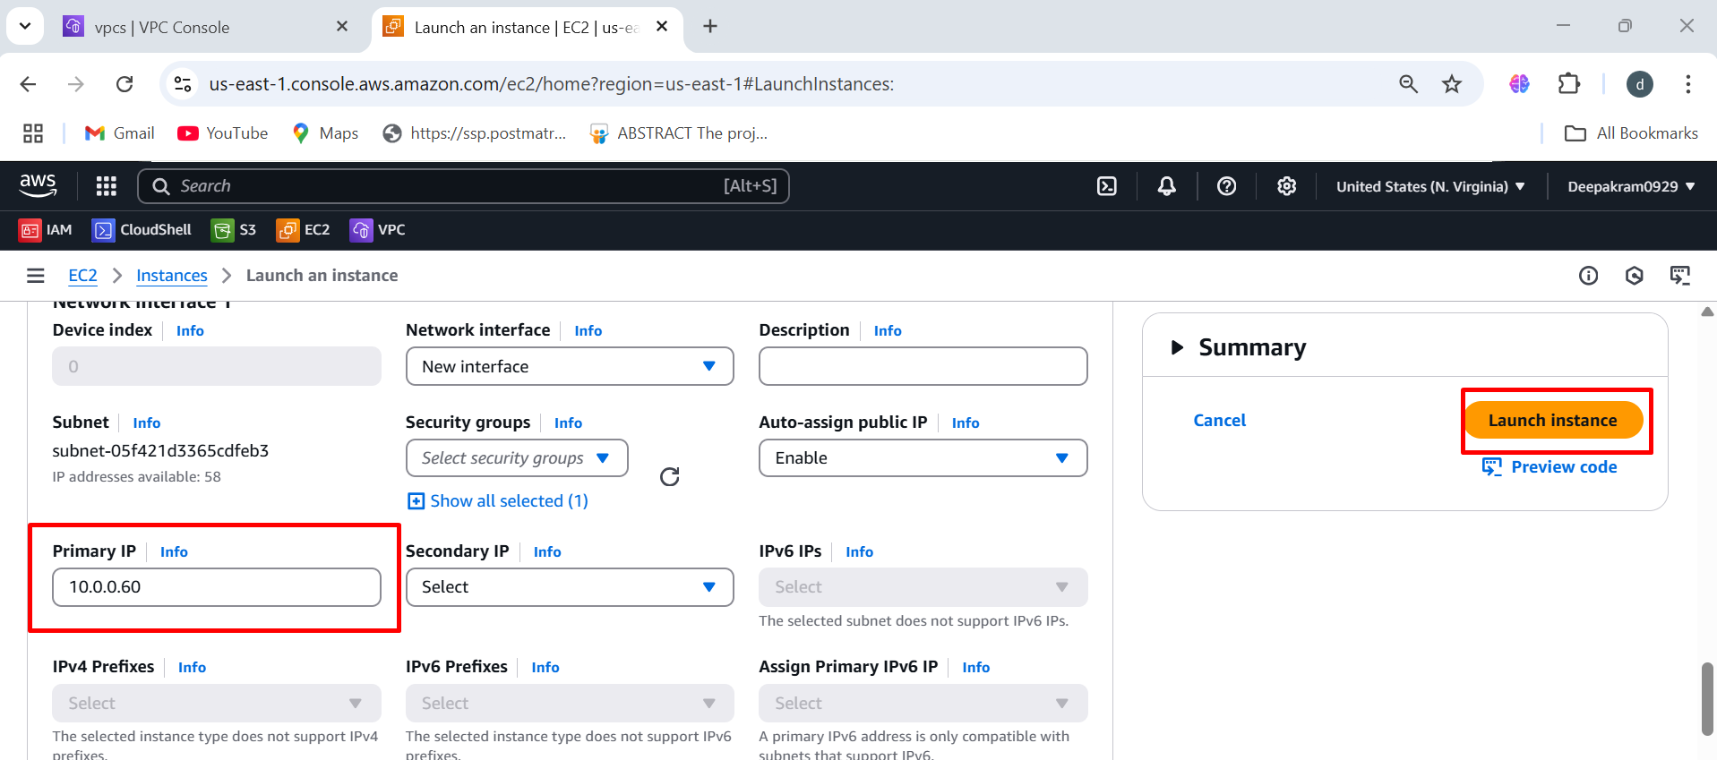

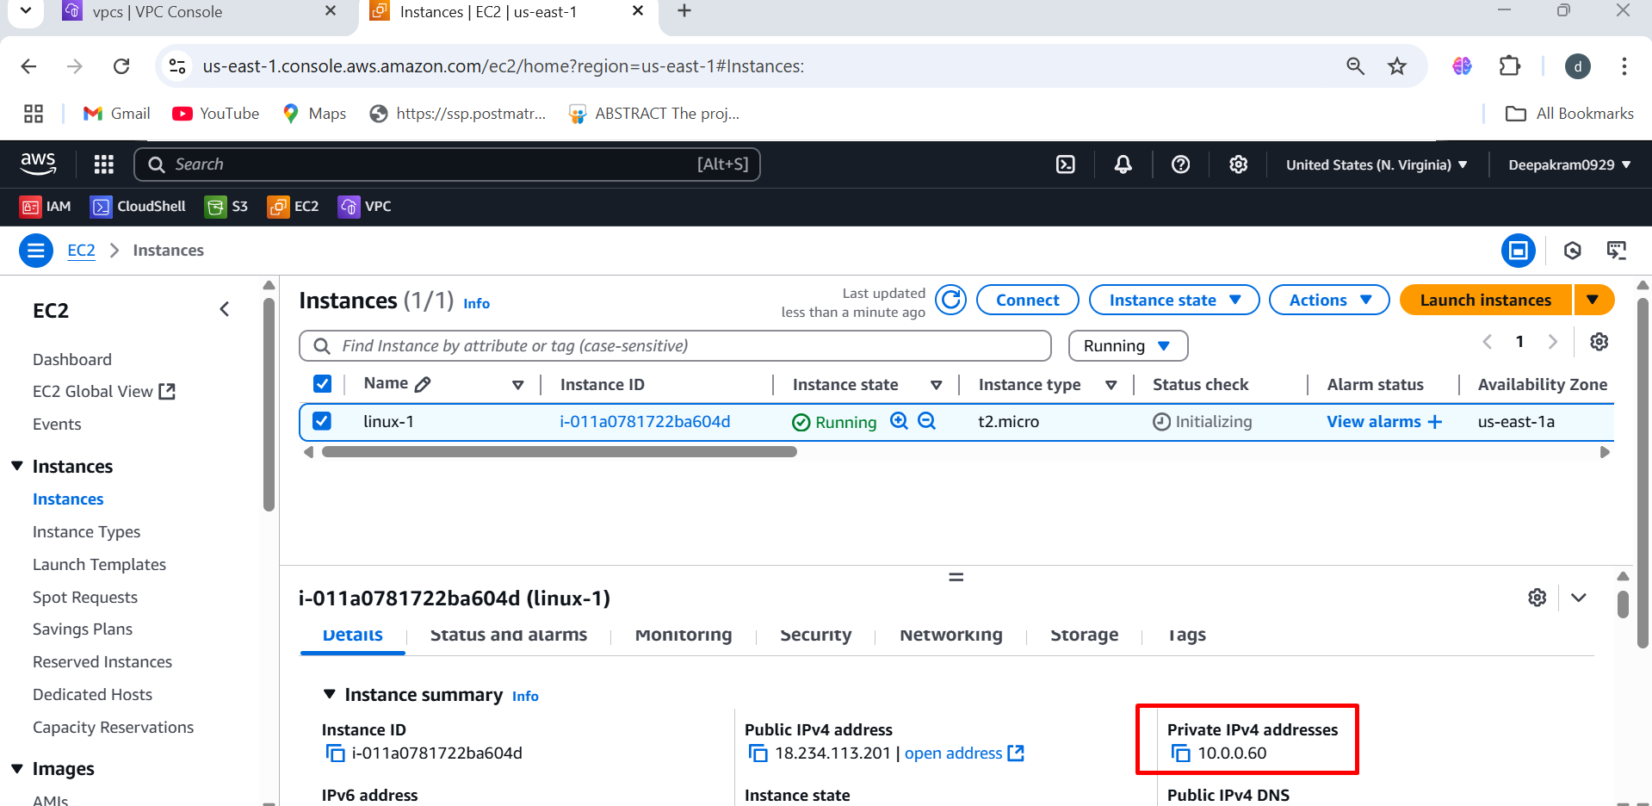

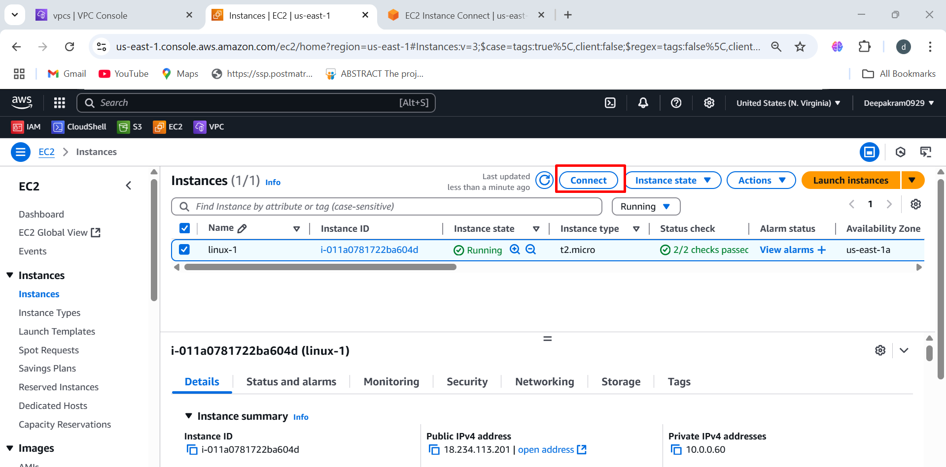

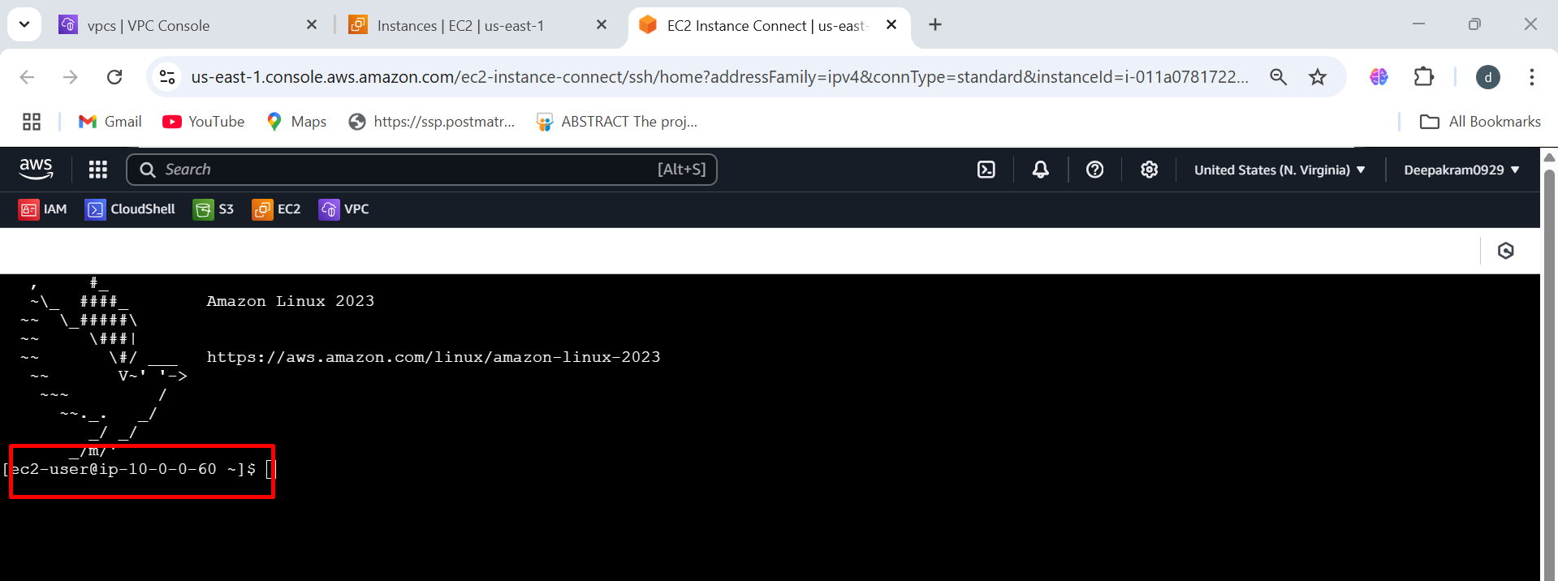

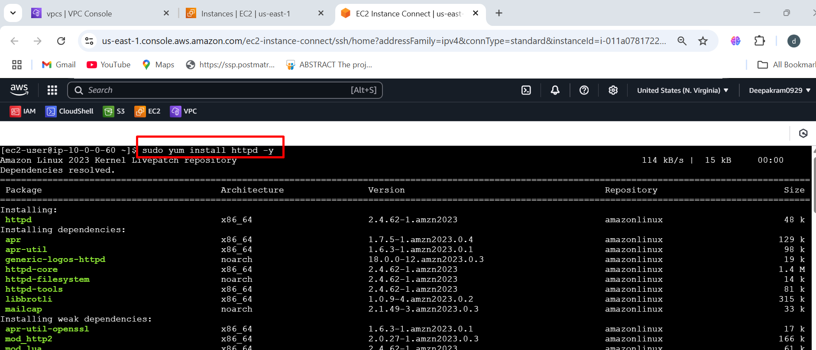

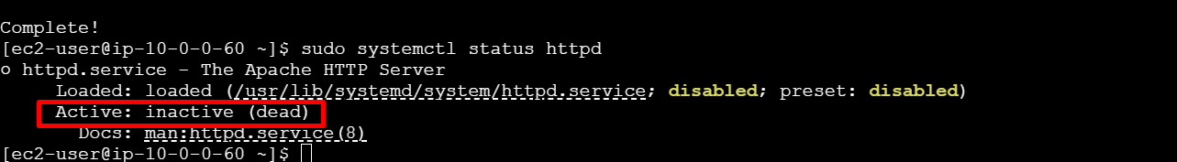



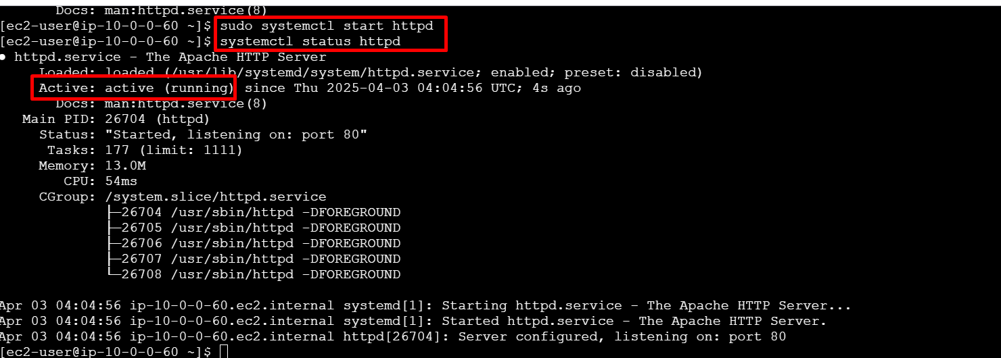

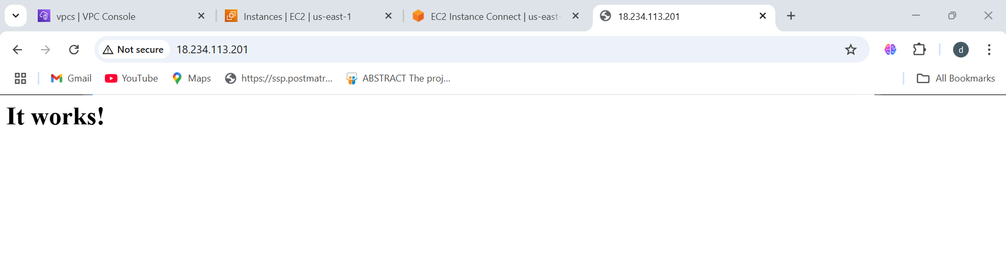

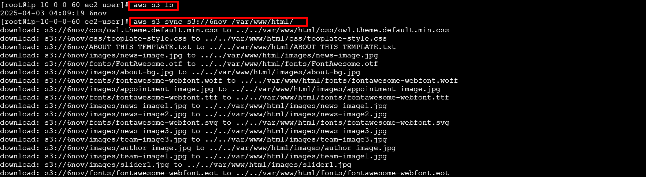



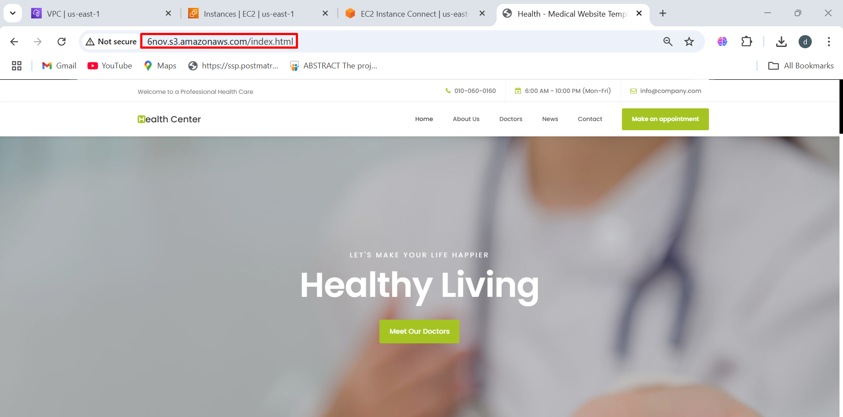

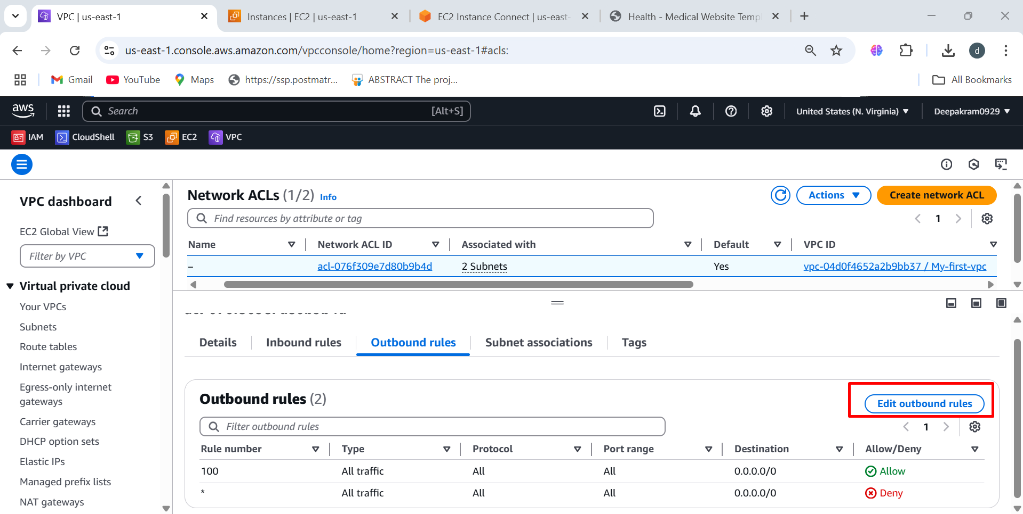

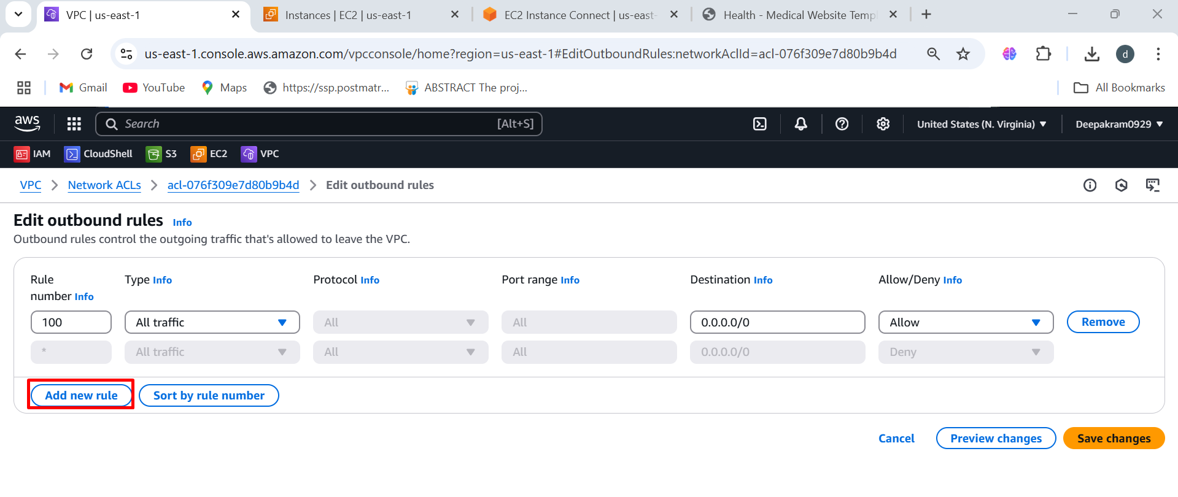

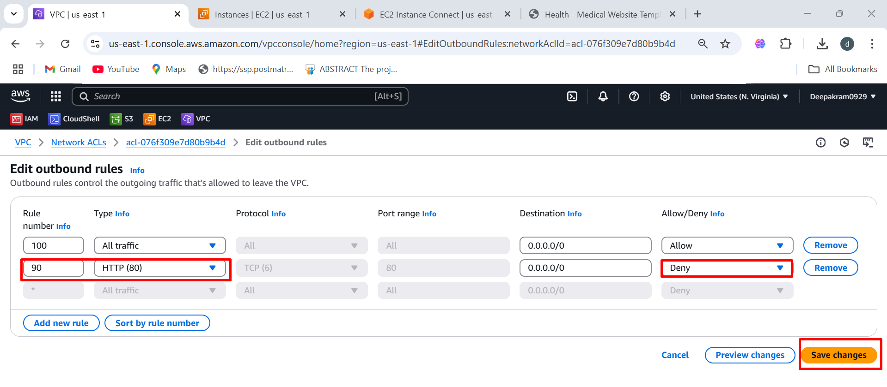

**Troubleshooting**

